Commute time in the United States will be investigated in this handout. The goal here is to obtain a reasonable estimate for Mean Commute Time using data provided by the US Census Bureau.
WNYC Average Commute Time by Zipcode

Source: https://project.wnyc.org/commute-times-us/embed.html#5.00/38.272/-96.224

The Census Bureau now has an application program interface (API) that allows one to obtain census data. Here, the Mean Commute Time is being returned for commuters in the United States.
https://api.census.gov/data/2015/acs5/profile?get=NAME,DP03_0025E&for=us:*
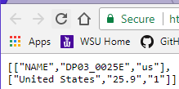
The possible list of variables for American Community Survey 5 Year dataset is provided by the following link.
ACS 5 Year List of Variables: https://api.census.gov/data/2015/acs5/profile/variables.html
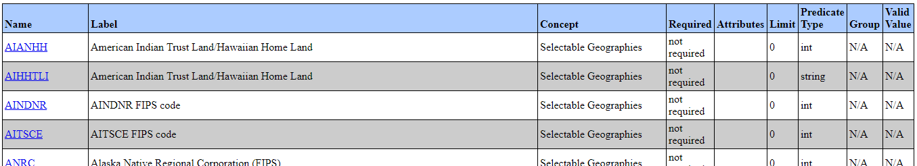

The CommuteData_Zipcode.csv file will be used as the sampling frame for this handout. A snipit of this data is shown here.
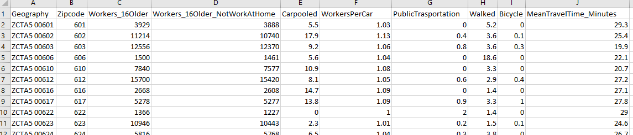

Simple Random Sampling in R
First, reading in the CommuteData_Zipcode Data into R. Use the View() function to ensure the data was read in correctly.
Commute <- read.csv( file.choose() )
View(Commute)

Using the filter() function in dplyr package to remove missingness from variables of interest.
library(dplyr)
Commute2 <- filter(Commute,!is.na(MeanTravelTime_Minutes))

Using the sample command to take a random sample of n=500 from the Commute2 data.frame.
mysample<-sample(1:30868,size=500,replace=FALSE)

Computing the mean of Mean Travel Time using the summarize() function.
summarize(Commute2[mysample,], 'Mean'= mean(MeanTravelTime_Minutes))

Creating a simple R function to do the simple random sampling from the Commute2 data.frame.
MySim_SRS <- function(){
mysample<-sample(1:30868,size=500,replace=FALSE)
output<-summarize(Commute2[mysample,], 'Mean'= mean(MeanTravelTime_Minutes))
return(output)
}
Using the replicate() function in R to run the MySim_SRS() function repeatedly.
> SRS_Output <- data.frame( "Estimates" = unlist( replicate(2, MySim_SRS() ) ) )
A quick look at breaking down this code
R Code | Description
> MySim_SRS()  Mean  1 25.764  > MySim_SRS()  Mean  1 25.9086 | Running the MySim_SRS() function.  The output is being returned to the screen here.
> replicate(2, MySim_SRS() )  $Mean  [1] 26.2106  $Mean  [1] 25.6342  Confirmation that replicate() function indeed returns a list data type in R.  > testdata <- replicate(2,  MySim_SRS() )  > str(testdata)  List of 2  $ Mean: num 25.8  $ Mean: num 25.3 | The replicate function will run the MySim_SRS() repeatedly – only 2 iterations are being specified here.  The output is from the replicate() function is returned as a list. Notice the slightly different appearance of the output.  The structure, i.e. str(), function in identifies that this is indeed a list object in R.
> unlist(replicate(2,MySim_SRS() ))  Mean Mean  25.7254 26.1924 | The unlist() function here will reduce a list object to a simple vector.
> SRS_Output <- data.frame(  "Estimates" = unlist(  replicate(2, MySim_SRS() )  )  )  SRS_Output  Estimates  1 25.9318  2 26.0690 | The final step is the put the output back into a data.frame object in R so that standard summaries and ggplot commands will work correctly.

The goal in sampling is to provide estimates that mimic the target population as closely as possible (no bias) with high precision (low sampling error).
Target Population Quantity: 25.9 | Study Population Quatity: 25.87  > summarize(Commute2,"Overall Mean" = mean(MeanTravelTime_Minutes) )  Overall Mean  1 25.8655
Using the replicate() function to obtain several thousands repeated outcomes using the simple random sampling approach.
> SRS_Output <- data.frame( "Estimates" = unlist( replicate(5000, MySim_SRS() ) ) )
Getting the overall mean from all the repeated iterations can be obtained using the following.
> summarize(SRS_Output, "Overall Mean" = mean(Estimates) )
Overall Mean
1 25.86801

Bias in Estimate = (Estimate – Target)
Calculate the bias in our estimates when simple random sampling is done with sample size n = 500.
Bias =
A more thorough approach might be to calculate the bias for each individual
> SRS_Output = mutate(SRS_Output, "Bias" = Estimates - 25.87)

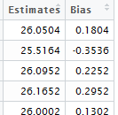

> summarize(SRS_Output, "Overall Mean" = mean(Bias) )
Overall Mean
1 -0.00199312

> summarize(SRS_Output, "Median" = median(Bias) )
Median
1 -0.0058

Plotting the distribution of bias.
> ggplot(SRS_Output, aes(Bias)) + geom_dotplot(binwidth=0.01)

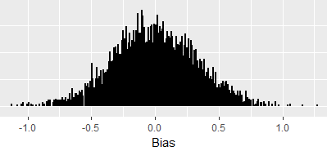
The following can be used to compute the proportion of estimates that under-estimated the actual target.
> length(which(SRS_Output$Bias < 0)) / 5000
[1] 0.5066

The precision of the estimates can be determined by looking at the standard deviation of the Estimates.
> summarize(SRS_Output, "Std Dev" = sd(Estimates) )
Std Dev
1 0.3266106

Precision of the estimates can be obtained by way of statistical theory as well.
$$Standard Error= \frac{σ}{\sqrt{n}}$$
Getting the standard deviation of the target population…
> summarize(Commute2, "Std Dev" = sd(MeanTravelTime_Minutes) )
Std Dev
1 7.447405

> summarize(Commute2, "Std Dev" = sd(MeanTravelTime_Minutes) ) / sqrt(500)
Std Dev
1 0.333058
Consider the following modification to the MySim_SRS() function. This modification will allow us to easily change the number of observations being drawn from the “hat”. A default value of sample size = 500 is being specified here; thus, if the function is run without a sample size specification, the function will use 500.
MySim_SRS <- function(samplesize=500){
mysample<-sample(1:30868,size=samplesize,replace=FALSE)
output<-summarize(Commute2[mysample,], 'Mean'= mean(MeanTravelTime_Minutes))
return(output)
}

R Code | Description
> MySim_SRS(samplesize=100) | The mean from a simple random sample of  size = 100 will be returned from the  MySim_SRS() function.
> MySim_SRS() | The mean from a simple random sample of  size = 500 (the function will use the default value) will be returned from the MySim_SRS() function.

The following command can be used to obtain 5000 repeated simulations, each sample taken is a simple random sample of size 100. The output should be labeled in such a way to indicate that sample size = 100.
> SRS_Output100 <- data.frame( "Estimates" = unlist( replicate(5000, MySim_SRS(samplesize=100) ) ) )
Tasks:
- Obtain several thousand repeated simulations using a sample size of 100. Use ggplot() to plot the mean estimates. Discuss what you see in this plot? Does there appear to be bias present? Is the variability in these estimates higher/lower than the distribution when using sample size = 500.
- Calculate the bias for each mean estimate. Use ggplot() to plot the bias distribution. Is this distribution centered about 0? Should it be centered about 0? Discuss.

- Calculate the standard deviation in the mean estimates from your simulation. Calculate the standard error using the formula provided above. To what degree do these estimates agree? Discuss.

- Repeat Tasks 1 -3 using a sample size = 400. Discuss the resulting bias and standard error from samples of size 400.

- Someone not so familiar with math suggests that doubling the sample size should cut the standard error in half. Someone else suggest that quadrupling the sample size should cut the standard error in half. Who is correct and why?
PROBLEM: NOT ALL ZIPCODES HAVE SAME NUMBERS OF WORKERS; THUS, COMPUTING AN AVERAGE ACROSS ZIPCODES NEEDS TO BE CAREFULLY CONSIDERED.
Creating an updated data.frame that includes the Total Travel Time.
> Commute3 <- mutate(Commute2, 'TotalTravelMinutes' = Workers_16Older_NotWorkAtHome * MeanTravelTime_Minutes)

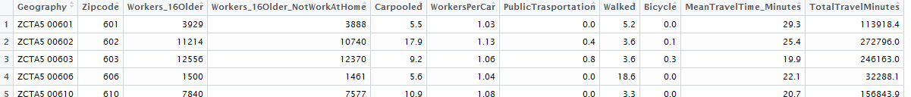
Updating the MySim_SRS() function to reflect the need to compute an “improved” estimate.
> MySim_SRS <- function(samplesize=500){
mysample<-sample(1:30868,size=samplesize,replace=FALSE)
output<-summarize(Commute3[mysample,], 'Mean'= sum(TotalTravelMinutes) /
sum(Workers_16Older_NotWorkAtHome))
return(output)
}
Again, getting 5000 repeated simulations…
> SRS_Output500 <- data.frame( "Estimates" = unlist( replicate(5000, MySim_SRS(samplesize=500) ) ) )
> SRS_Output500 = mutate(SRS_Output500, "Bias" = Estimates - 25.87)

Creating a plot of the bias…
> ggplot(SRS_Output500, aes(Bias)) + geom_dotplot(binwidth=.02)

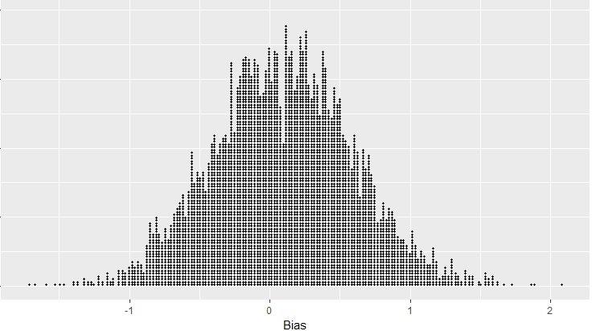
> length(which(SRS_Output500$Bias < 0)) / 5000
[1] 0.4286

The bias appears to be larger (not smaller) than using the unweighted approach. What might be causing this problem?

