What Needs To Happen in our Simulation
Before writing code, let us first understand what needs to happen in our simulation code. There are two tables that will be used for this simulation study. The Explanatory table that provides the demographic or background information about each study participate and the Response table that provides the outcome for each study participate.
Explanatory Table  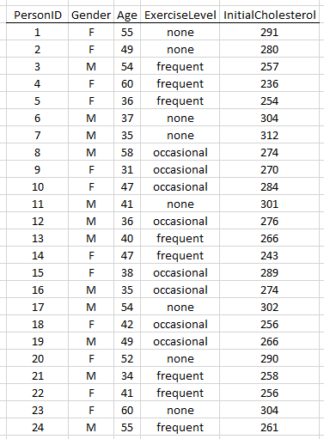 |  | Experimental units must be assigned completely at random to each of the two treatments.  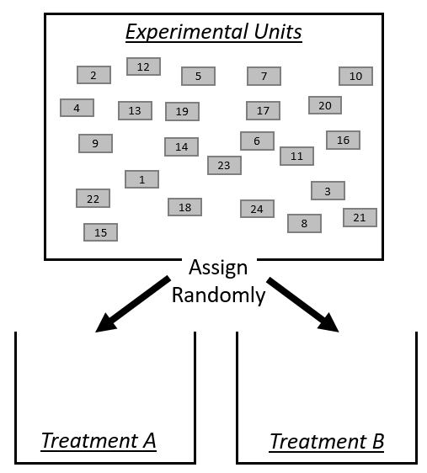

The first step is to randomly assign the various treatments to each of the study participants.
The random assignment  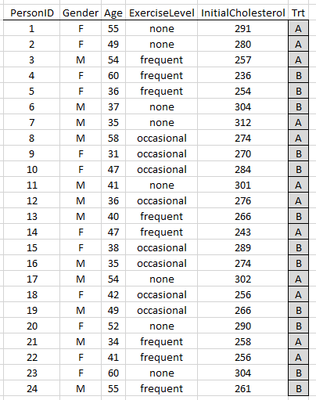 |  | Randomly assign units to treatments  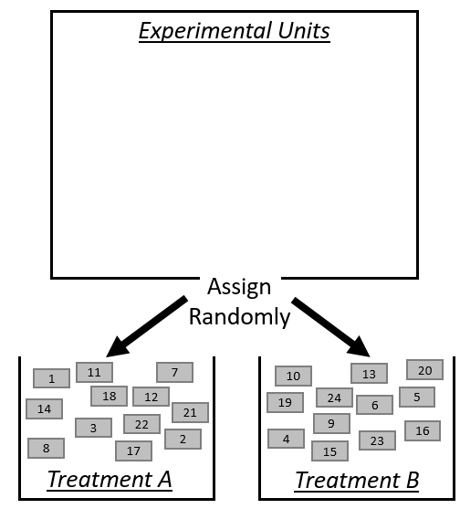

The next step is to “run the experiment”. For our simulation study, this means we will use a Lookup table to assign the appropriate response for each person in our study.
Experiment Data  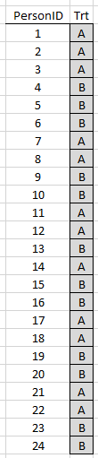 | Lookup Tables for “Running The Experiment”  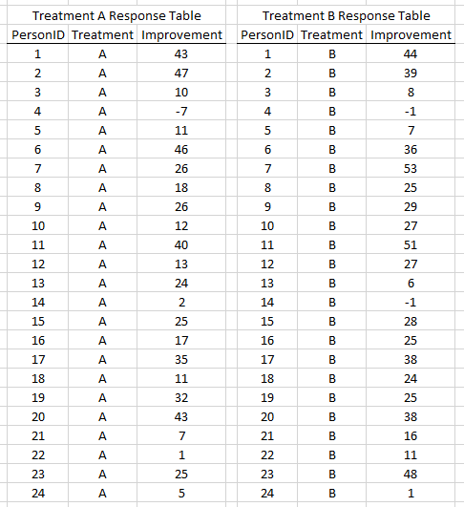

After all lookups have been completed, merge the response data to the Experiment Data as is shown here.
Merge outcomes to Experiment Data  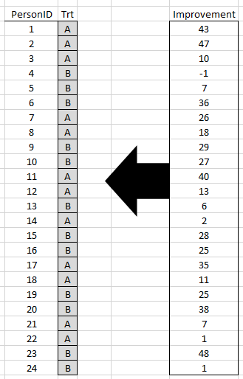 | Final Experiment Data for analysis  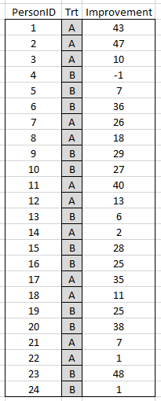
The appropriate analysis here is an Analysis of Variance (ANOVA). The ANOVA approach will allow us to easily extend to the inclusion of a blocking variable in our simulation study.
Getting the Analysis Done in R
The general syntax for fitting a model in R has the following form.
Response ~ Treatment
The following R code will be used to run the ANOVA model. The dataset being used by this function is called ExperimentData. The summary() function will produce the standard analysis of variance table.
#Reading in a csv file containing the random assignment obtained above
ExperimentData <- read.csv( file.choose() )

#Simple ANOVA
ANOVA_Output <- aov(Improvement~ Trt, data=ExperimentData)

#Getting the ANOVA table
summary(ANOVA_Output)

Output from R
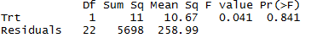
The following null and alternative hypothesis are being tested by this ANOVA analysis.
Hypotheses
H_{O} : The Average Improvement is the SAME
H_{A} : The Average Improvement is DIFFERENT
P-Value: ________________
Decision: If p-value < 0.05, then have enough evidence to reject H_{O}. Write a conclusion.

Understanding the Decomposition of Error in ANOVA.
Consider the following discussion centered on the decomposition of error terms in the usual analysis of variance model.
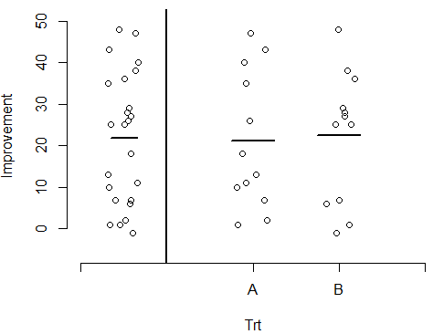 | Treatment Averages  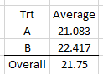

The “Sums of Squares Error - Total” is computed using the overall average. This calculation is being done assuming the treatments have no effect.
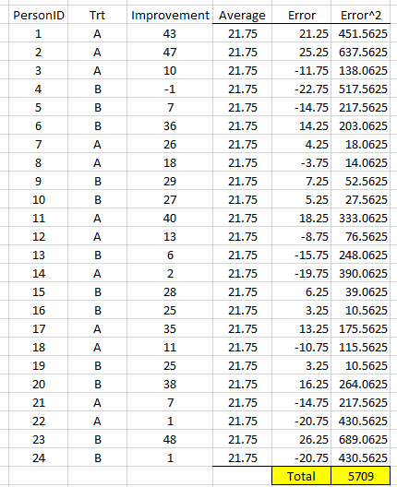

Visually, the sums of squares error – total is shown on the left. The sums of squares error is computing in a similar way except using the individual treatment means.
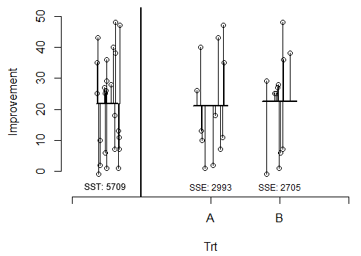
The “Sums of Squares Error” is computed using the individual treatment averages. This calculation is being done assuming the treatments have some effect.
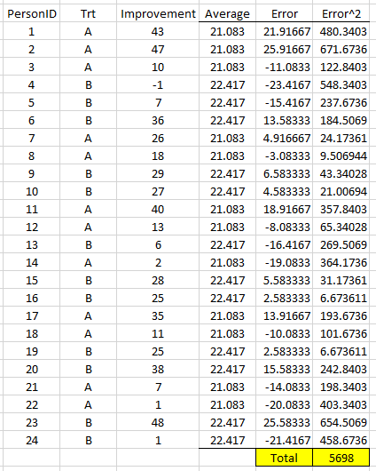
This Sums of Squares Error measures the amount of variation in the outcomes that cannot be explained by the treatments. This is in contrast to the “Sums of Squares Treatment” which is the amount of variation that can be explained by the treatments.
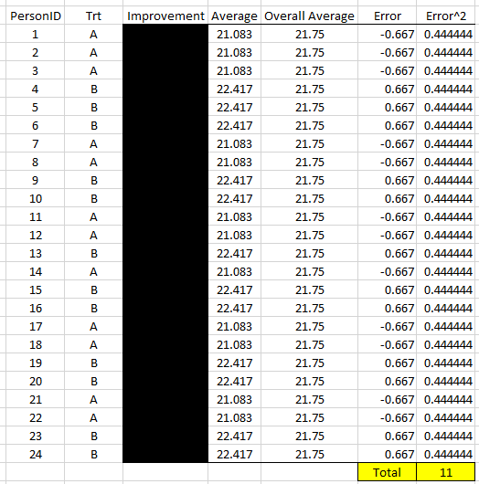

Building the Simulation Study in R
Reading the two data tables in R can be done using the following code. The file.choose() version below uses the Explorer/Finder window to locate the file to be read in.
#Reading in the data containing the experimental units
Explanatory <- read.csv( file.choose() )

#Reading in the data containing the possible responses
Response <- read.csv( file.choose() )
An alternative to using file.choose() is to provide the exact system path to the data to be read into R, e.g. “C:/Deskstop/Data.csv”.
Explanatory <- read.csv("<exact system path to file>")

The following can be used to make the random assignment of the experimental units to each of the two treatments.
#Get a sequence for the treatments
Treatments <- c("A","A","A","A","A","A","A","A","A","A","A","A","B","B","B","B","B","B","B","B","B","B","B","B")
#Get one random assignment using the sample() function, without replacement
RandomAssignments <- sample(c(1,2,3,4,5,6,7,8,9,10,11,12,13,14,15,16,17,18,
19,20,21,22,23,24) ,
replace=FALSE
)
Building a data.frame in R to merge the PersonID and the random assignments obtained above.
ExperimentData <- data.frame('PersonID' = RandomAssignments, 'Trt'= Treatments)

Gather PersonID and RandomAssignment and merge together  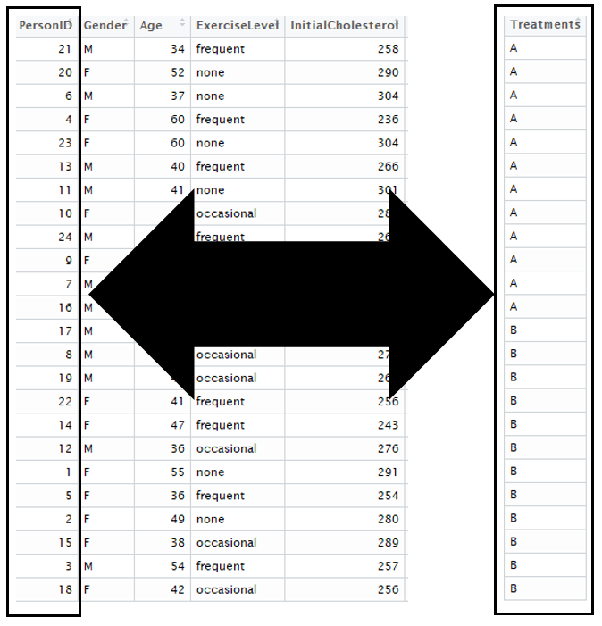 | Experiment Data  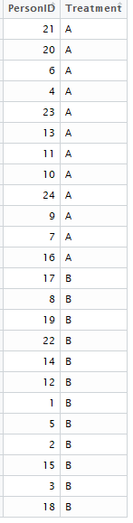
Next, we will use the left_join() function in the dplyr package in R to conduct the necessary lookup to attach the appropriate responses to each person in the study. If you have not previously done so, you will need to install the dplyr package. This can be done using RStudio’s Package installer.
library(dplyr)

ExperimentData <- left_join(ExperimentData,Response,
by=c(‘PersonID’ = ‘PersonID’,
‘Treatment’ = ‘Treatment’)
)

Experiment Data  before lookup | Response  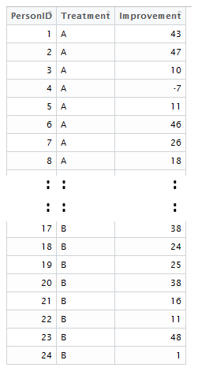 |  | Experiment Data  after lookup  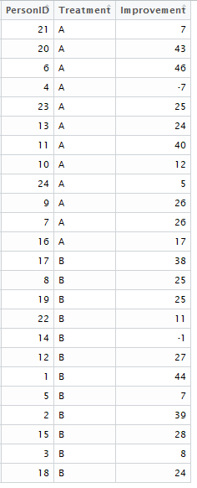

The ANOVA table for this analysis can be obtained as follows.
ANOVA_Output <- aov(Improvement ~ Treatment, data=ExperimentData)
summary(ANOVA_Output)

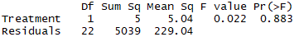

A simulation study will require us to repeatedly run the code above. The most succinct way of doing this in R is to place the code into a function as shown below. The outcome that will be obtained on each iteration is the “Sums of Squares Error” term from the ANOVA table.
MySimulation <- function(){

#Setting up the treatment
Treatment <- c("A","A","A","A","A","A","A","A","A","A","A","A","B","B","B",
"B","B","B","B","B","B","B","B","B")

#Getting the random assignment
RandomAssignments <- sample(c(1,2,3,4,5,6,7,8,9,10,11,12,13,14,15,16,17,18,
19,20,21,22,23,24),replace=FALSE)

#Creating the ExperimentData
ExperimentData <- data.frame('PersonID' = RandomAssignments,
'Treatment'= Treatment)

#Create a jOin to obtain the responses
ExperimentData <- left_join(ExperimentData,Response,
by = c('PersonID' = 'PersonID',
'Treatment' = 'Treatment')
)
ANOVA_Output <- aov(Improvement ~ Treatment, data=ExperimentData)
SSE_Value <- summary(ANOVA_Output)[[1]][2,2]

return(SSE_Value)
}
The replicate() function in R can be used to run repeated instances of a function. This will work well for a simulation study as the function written above needs to be run repeatedly. This will allow us to understand how much the random assignment influences the “Sums of Squares Error” term from each ANOVA analysis. A total of 100 repeated outcomes are obtained here.
SimulationOutcomes <- data.frame('SSE_Values' = replicate(100,MySimulation() ) )

To see the “Sums of Squared Error” values from each iteration of your simulation, you can simply type the object’s name in R.
SimulationOutcomes
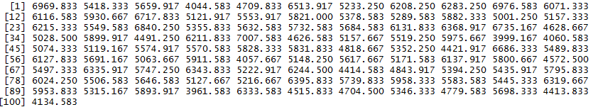

Basic summaries, e.g. graphs, summary statistics, etc., can be obtained easily in R. Here the ggplot() function (from the ggplot2 package) is being used to create a dotplot and the summarize() function (from the dplyr package) is being used to obtain the mean and standard deviation of the distribution of “Sums of Squares Error” values from the 100 simulated iterations.
The following ggplot() function can be used to obtain a simple dotplot of these 100 simulated outcomes.
library(ggplot2)

ggplot(SimulationOutcomes,aes(x=SSE_Values)) + geom_dotplot()

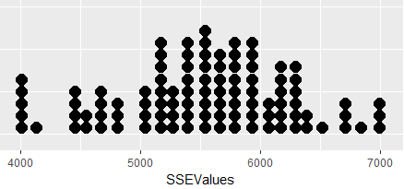
The summarize() function which is part of the dplyr library can be used to obtain basic summary statistics of your simulated outcomes.
> summarize(SimulationOutcomes,’Mean’ = mean(SSE_Values))
Mean
1 5532.738
> summarize(SimulationOutcomes,’Standard Deviation’ = sd(SSE_Values))
Standard Deviation
1 716.0141

Modification for Blocking
When an experiment includes a blocking variable, the randomization of treatments to subjects will be modified. In particular, the randomization is restricted in the sense that random assignment is done within each block.
Define blocking variable  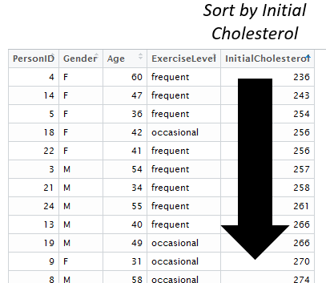 | Form the blocks  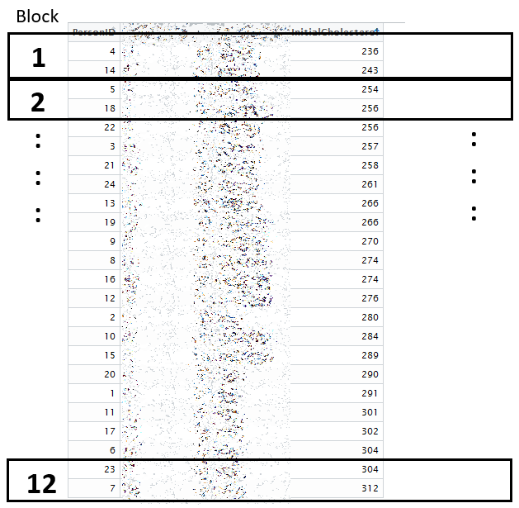

#Getting the dplyr library to join the ExperimentData with the Responses
library(dplyr)

#Sort the data.frame by InitialCholesterol
Explanatory_ByCholesterol <- arrange(Explanatory, InitialCholesterol)

#Adding a variable to data.frame to identify the block
Explanatory_ByCholesterol <- mutate(Explanatory_ByCholesterol,
'Block' = rep(1:12,each=2))
The random assignment of subjects to treatments must take place within each block in a randomized block design; this is in contrast to the assignment of treatments in a completely randomized design.
First, consider the subjects from Block 1
Next, randomly assign the two subjects in Block 1 to the two treatments | 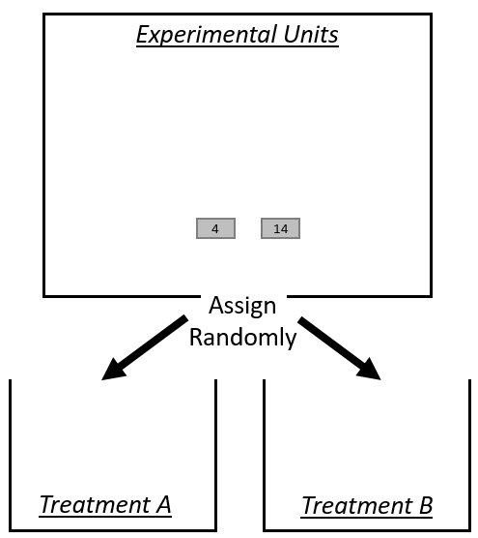 | 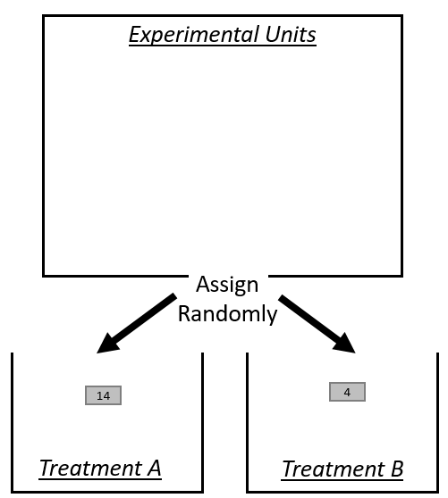
After making the assignment, keep relevent informaiton for model fitting | 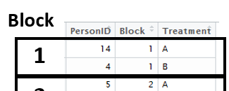
Repeat the random assignment of subjects to treatments for all blocks…

The following code can be used to do the random assignment of treatments within each block, merge the random assignments with PersonID and then synthetically run the experiment using the lookup table.
#Make Treatment Assignments (within each Block)
Treatment <- rep(c("A","B"),times=12)

#Getting one random assignment
RandomAssignments <- Explanatory_ByCholesterol %>% group_by(Block)
%>% sample_n(2,replace=F) %>% select(PersonID,Block)

ExperimentData <- data.frame(RandomAssignments, 'Treatment'= Treatment)

#Doing the join to get response data
ExperimentData <- left_join(ExperimentData,Response,
by = c('PersonID' = 'PersonID',
'Treatment' = 'Treatment')

)

The code above creates the ExperiementData which will be used to conduce the analysis.
Experiment Data  before lookup  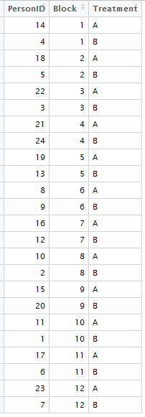 | Lookup table to run the experiment  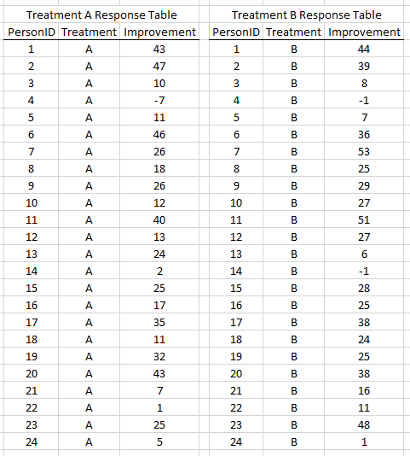 | Experiment Data  after lookup  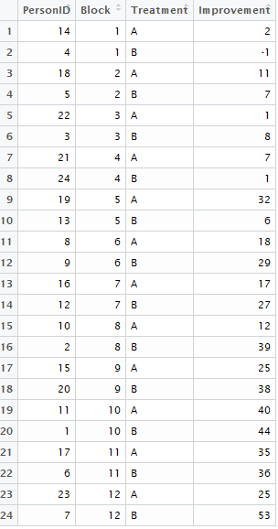
The following code conducts a one-way analysis of variance with the inclusion of the blocking variable.
#Get ANOVA analysis with blocking and get ANOVA table

ANOVA_Output <- aov(Improvement ~ Treatment + Block, data=ExperimentData)
summary(ANOVA_Output)

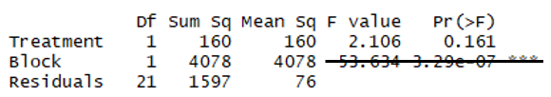
The following null and alternative hypothesis are being tested by this ANOVA analysis.
Hypotheses
H_{O} : The Average Improvement is the SAME
H_{A} : The Average Improvement is DIFFERENT
P-Value: ________________
Decision: If p-value < 0.05, then have enough evidence to reject H_{O}. Write a conclusion.

What happens when the analysis ignores the blocking variable?
#Anayzing the Data
outcomes <- aov(Improvement ~ Treatment, data=ExperimentData)
summary(outcomes)

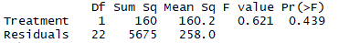

Notice that the Sums of Squares for the blocking variable have been dumped into the Sums of Squares for Residuals, i.e. the unexplained variation. The result is that the test of significance no longer can detect the difference between Treatment A and B.

Next, we will place the code for the block simulation into a function so that this code can be easily run on repeated iterations.
MyBlockSimulation <- function(){

#Make Treatment Assignments (within each Block)
Treatment <- rep(c("A","B"),times=12)

#Getting one random assignment
RandomAssignments <- Explanatory_ByCholesterol %>% group_by(Block)
%>% sample_n(2,replace=F) %>% select(PersonID,Block)

ExperimentData <- data.frame(RandomAssignments, 'Treatment'= Treatment)

#Doing the join
ExperimentData <- left_join(ExperimentData,Response,
by = c('PersonID' = 'PersonID',
'Treatment' = 'Treatment')

)

#Get ANOVA analysis and get the ANOVA table
ANOVA_Output <- aov(Improvement ~ Treatment + Block, data=ExperimentData)
SSE_Value <- summary(ANOVA_Output)[[1]][3,2]

return(SSE_Value)
}

The replicate function is again used to run 100 repeated iterations.

BlockSimulationOutcomes <- data.frame('SSE_Values' = replicate(100,MyBlockSimulation() ) )

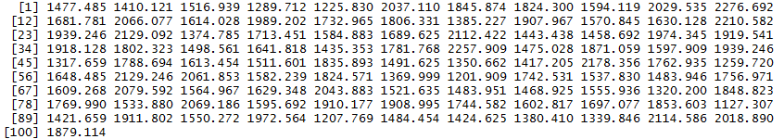
Plotting these outcomes and obtaining basic summary statistics for these outcomes.
ggplot(BlockSimulationOutcomes,aes(x=SSEValues)) + geom_dotplot()

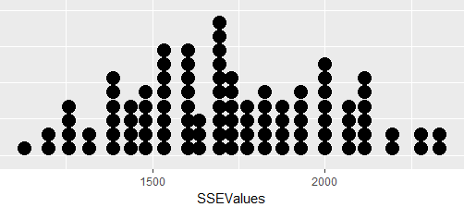

> summarize(BlockSimulationOutcomes,’Mean’ = mean(SSEValues))
Mean
1 1719.937
> summarize(BlockSimulationOutcomes,’SD’ = sd(SSEValues))
SD
1 283.9971
The following can be used to plot all the outcomes at once for comparison purposes.
#Putting the two simulation outcomes together
SimulationOutcomes<-mutate(SimulationOutcomes,’Type’ = "CRD")
BlockSimulationOutcomes<-mutate(BlockSimulationOutcomes,’Type’ = "Block")
AllSimulationOutcomes <- bind_rows(SimulationOutcomes, BlockSimulationOutcomes)

#ggplot to compare
ggplot(AllSimulationOutcomes, aes(x=SSE_Values)) +
geom_dotplot(binwidth=100) +
theme(axis.title.y=element_blank(),
axis.text.y=element_blank(),
axis.ticks.y=element_blank()) +
scale_x_continuous(limits=c(0,8000)) +
facet_wrap(~ Type, ncol=1)

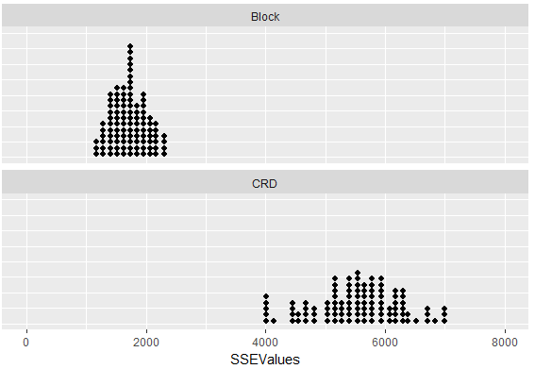

Task: Set up a simulation study to investigate the effect of blocking by Gender. Obtain a distribution SSE Values and compare against the values obtained here.

