Scenario 1: Completely Randomized Design
- What were the mean and standard deviation of the sample means
Treatment | Mean | Standard Deviation
A
B

- Sketch boxplots of the results.
Results from you and your classmates:
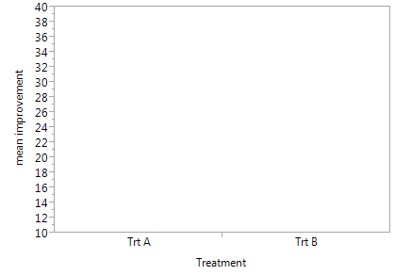

Here is what was obtained when a computer was used to randomize treatments under this design 1,000 times:
Treatment A:
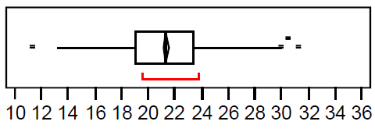

Treatment B:
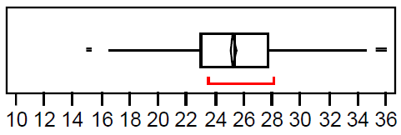

Scenario 2: Randomized Complete Block Design (Blocking by Age)
- What were the mean and standard deviation of the sample means?
Treatment | Mean | Standard Deviation
A
B

- Sketch boxplots of the results.
Results from you and your classmates:

Here is what was obtained when a computer was used to randomize treatments under this design 1,000 times:
Treatment A:
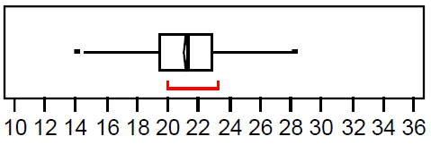
Treatment B:
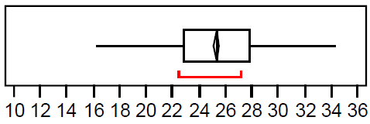

Scenario 3: Randomized Complete Block Design (Blocking by Initial Cholesterol)
- What were the mean and standard deviation of the sample means?
Treatment | Mean | Standard Deviation
A | 21.3 | 2.5
B | 25.1 | 1.6

- Sketch boxplots of the results.
Results from you and your classmates:
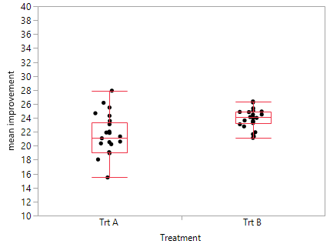

Here is what was obtained when a computer was used to randomize treatments under this design 1,000 times:
Treatment A:
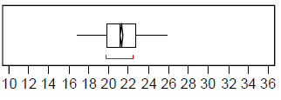
Treatment B:
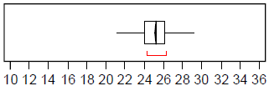

Scenario 4: Randomized Complete Block Design (Blocked by Gender and Initial Cholesterol)
- What were the mean and standard deviation of the sample means?
Treatment | Mean | Standard Deviation
A | 22.0 | 2.5
B | 25.6 | 2.8

- Sketch boxplots of the results.
Results from you and your classmates:
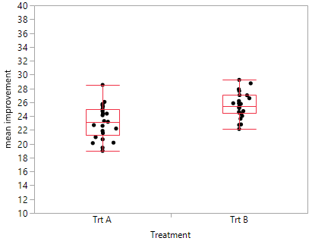

Here is what was obtained when a computer was used to randomize treatments under this design 1,000 times:
Treatment A:
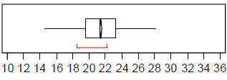
Treatment B:
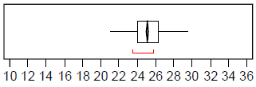
Scenario 5: Randomized Complete Block Design (Blocked by Exercise & Initial Cholesterol)
- What were the mean and standard deviation of the sample means?
Treatment | Mean | Standard Deviation
A
B

- Sketch boxplots of the results.

Results from you and your classmates:

Here is what was obtained when a computer was used to randomize treatments under this design 1,000 times:

Treatment A:
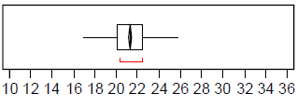
Treatment B:
