Suppose we are setting up an experiment to compare the effectiveness of two drugs (A and B) that are intended to lower cholesterol levels. The experiment will involve 24 subjects. Your job is to assign them to treatments and determine which drug is more effective.
In this activity, we won’t actually be able to perform this experiment. Instead, we will use simulated data that mimics results that are typically obtained in such studies. The data used is shown at the end of this handout. In an actual experiment, we wouldn’t know the values in the last two columns until after the experiment was conducted (and then only half of the values would be known, since only half of the subjects would have received each treatment). Do your best to pretend that these data are not available when you assign the treatments to subjects.
Scenario 1: Completely Randomized Design
Consider the data set as sorted by age. Randomly assign 12 subjects to Drug A and the other 12 to Drug B. Then, record the improvement of each subject after treatment with his/her assigned drug in the table below, and calculate the mean improvement for each drug.
Row # | Improvement after A | Row # | Improvement after B
Mean improvement after A |  | Mean improvement after B
Questions:
- In this single simulation of the experiment, which drug did a better job of reducing cholesterol?
- Combine your results with the rest of the class. How many times was A better? ______ How many times was B better? ______
- What were the mean and standard deviation of the sample means for each treatment?
Treatment | Mean | Standard Deviation
A
B

- Sketch parallel boxplots of the sample means obtained on the graph below.
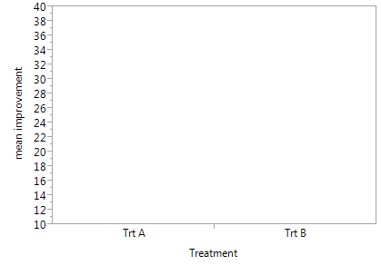

Scenario 2: Randomized Complete Block Design (Blocking by Age)
Again, refer to the table that is sorted by age. This time, divide the subjects into 12 blocks of size 2 according to age (the first two subjects form a block, the second two subjects form a block, etc.). Then, randomize the subjects to receive either Drug A or Drug B within each block. Record the improvement of each subject after treatment with his/her assigned drug in the table below, and calculate the mean improvement for each drug.

Row # | Improvement after A | Row # | Improvement after B
Mean improvement after A |  | Mean improvement after B

Questions:
- In your simulation, which drug did a better job of reducing cholesterol?
- Combine your results with the rest of the class. How many times was A better? ______ How many times was B better? ______

- What were the mean and standard deviation of the sample means for each treatment?
Treatment | Mean | Standard Deviation
A
B

- Sketch parallel boxplots of the sample means obtained on the graph below.

- How do these results compare to Scenario 1? Compare the means and standard deviations as well as the overlap in the boxplots.
- What do you conclude about the effectiveness of age as a blocking variable?

Scenario 3: Randomized Complete Block Design (Blocking by Initial Cholesterol)
This time, refer to the table that is sorted by initial cholesterol. Divide the subjects into 12 blocks of size 2 according to initial cholesterol (the first two subjects form a block, the second two subjects form a block, etc.). Then, randomize the subjects to receive either Drug A or Drug B within each block. Record the improvement of each subject after treatment with his/her assigned drug in the table below, and calculate the mean improvement for each drug.
Row # | Improvement after A | Row # | Improvement after B
Mean improvement after A |  | Mean improvement after B

Questions:
- In your simulation, which drug did a better job of reducing cholesterol?
- Combine your results with the rest of the class. How many times was A better? ______ How many times was B better? ______

- What were the mean and standard deviation of the sample means for each treatment?
Treatment | Mean | Standard Deviation
A
B

- Sketch parallel boxplots of the sample means obtained on the graph below.
- How do these results compare to Scenario 1? Compare the means and standard deviations as well as the overlap in the boxplots.
- How do these results compare to Scenario 2?
- What do you conclude about the effectiveness of initial cholesterol as a blocking variable?

Scenario 4: Randomized Complete Block Design (Blocked by Gender and Initial Cholesterol)
You should have just noted that blocking by initial cholesterol helps to reduce the variability in the sample means for Drugs A and B. To further reduce the variability, researchers often block on more than one variable. For this scenario, we will block by both gender and initial cholesterol. We have already shown that initial cholesterol is an effective blocking variable, and we’re choosing gender, as well, because it often creates variability in clinical trials.
Once again, refer to the table that is sorted by initial cholesterol. Divide the subjects into 12 blocks of size 2. Starting at the top, find the first two female subjects – this is your first block. Your second block is the next two female subjects, etc. The seventh block will be the first two male subjects. Randomize the subjects to receive either Drug A or Drug B within each block, and record the improvement of each subject after treatment with his/her assigned drug in the table below. Finally, calculate the mean improvement for each drug.
Row # | Improvement after A | Row # | Improvement after B
Mean improvement after A |  | Mean improvement after B

Questions:
- In your simulation, which drug did a better job of reducing cholesterol?

- Combine your results with the rest of the class. How many times was A better? ______ How many times was B better? ______
- What were the mean and standard deviation of the sample means for each treatment?
Treatment | Mean | Standard Deviation
A
B

- Sketch parallel boxplots of the sample means obtained on the graph below.
- How do these results compare to Scenario 1? Compare the means and standard deviations as well as the overlap in the boxplots.
- How do these results compare to Scenario 3?
- What do you conclude about the effectiveness of using both gender and initial cholesterol as a blocking variables?
Scenario 5: Randomized Complete Block Design (Blocked by Exercise & Initial Cholesterol)
Since gender did not help to reduce the variability any more so than initial cholesterol by itself, we will now ignore gender and instead use exercise level as an additional blocking factor.
Once again, refer to the table that is sorted by initial cholesterol. Divide the subjects into 12 blocks of size 2. Starting at the top, find the first two subjects that have exercise level “none” – this is your first block. Your second block is the next two subjects with exercise level “none,” etc. The fifth block will be the first two subjects with exercise level “occasional.” Randomize the subjects to receive either Drug A or Drug B within each block, and record the improvement of each subject after treatment with his/her assigned drug in the table below. Finally, calculate the mean improvement for each drug.
Row # | Improvement after A | Row # | Improvement after B
Mean improvement after A |  | Mean improvement after B
Questions:
- In your simulation, which drug did a better job of reducing cholesterol?
- Combine your results with the rest of the class. How many times was A better? ______ How many times was B better? ______
- What were the mean and standard deviation of the sample means for each treatment?
Treatment | Mean | Standard Deviation
A
B

- Sketch parallel boxplots of the sample means obtained on the graph below.
- How do these results compare to Scenario 1? Compare the means and standard deviations as well as the overlap in the boxplots.
- How do these results compare to Scenario 3?
- What do you conclude about the effectiveness of using both exercise level and initial cholesterol as a blocking variables?

When is Blocking Useful?
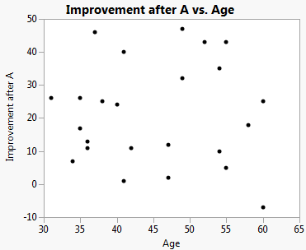 | 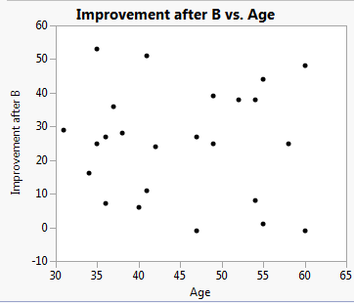
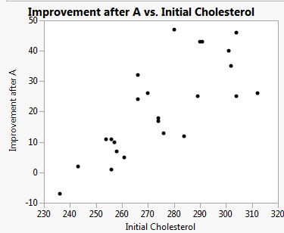 | 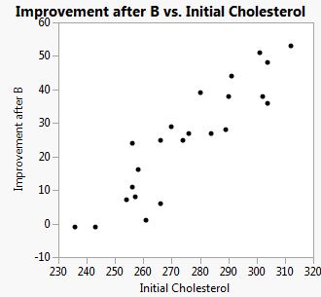
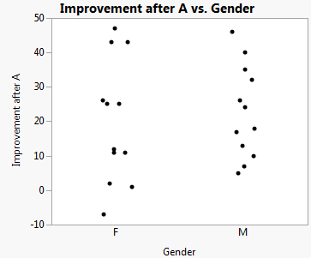 | 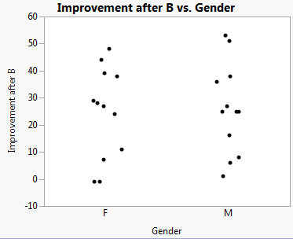
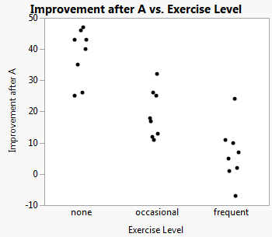 | 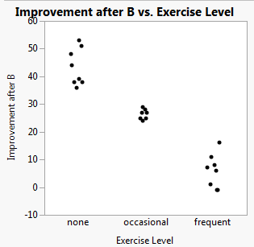

Sorted by Age
Row # | Gender | Age | Exercise Level | Initial Cholesterol | Improvement after A | Improvement after B
1 | F | 31 | occasional | 270 | 26 | 29
2 | M | 34 | frequent | 258 | 7 | 16
3 | M | 35 | occasional | 274 | 17 | 25
4 | M | 35 | none | 312 | 26 | 53
5 | F | 36 | frequent | 254 | 11 | 7
6 | M | 36 | occasional | 276 | 13 | 27
7 | M | 37 | none | 304 | 46 | 36
8 | F | 38 | occasional | 289 | 25 | 28
9 | M | 40 | frequent | 266 | 24 | 6
10 | F | 41 | frequent | 256 | 1 | 11
11 | M | 41 | none | 301 | 40 | 51
12 | F | 42 | occasional | 256 | 11 | 24
13 | F | 47 | frequent | 243 | 2 | -1
14 | F | 47 | occasional | 284 | 12 | 27
15 | M | 49 | occasional | 266 | 32 | 25
16 | F | 49 | none | 280 | 47 | 39
17 | F | 52 | none | 290 | 43 | 38
18 | M | 54 | frequent | 257 | 10 | 8
19 | M | 54 | none | 302 | 35 | 38
20 | M | 55 | frequent | 261 | 5 | 1
21 | F | 55 | none | 291 | 43 | 44
22 | M | 58 | occasional | 274 | 18 | 25
23 | F | 60 | frequent | 236 | -7 | -1
24 | F | 60 | none | 304 | 25 | 48

Sorted by Initial Cholesterol
Row # | Gender | Age | Exercise Level | Initial Cholesterol | Improvement after A | Improvement after B
1 | F | 60 | frequent | 236 | -7 | -1
2 | F | 47 | frequent | 243 | 2 | -1
3 | F | 36 | frequent | 254 | 11 | 7
4 | F | 41 | frequent | 256 | 1 | 11
5 | F | 42 | occasional | 256 | 11 | 24
6 | M | 54 | frequent | 257 | 10 | 8
7 | M | 34 | frequent | 258 | 7 | 16
8 | M | 55 | frequent | 261 | 5 | 1
9 | M | 40 | frequent | 266 | 24 | 6
10 | M | 49 | occasional | 266 | 32 | 25
11 | F | 31 | occasional | 270 | 26 | 29
12 | M | 35 | occasional | 274 | 17 | 25
13 | M | 58 | occasional | 274 | 18 | 25
14 | M | 36 | occasional | 276 | 13 | 27
15 | F | 49 | none | 280 | 47 | 39
16 | F | 47 | occasional | 284 | 12 | 27
17 | F | 38 | occasional | 289 | 25 | 28
18 | F | 52 | none | 290 | 43 | 38
19 | F | 55 | none | 291 | 43 | 44
20 | M | 41 | none | 301 | 40 | 51
21 | M | 54 | none | 302 | 35 | 38
22 | M | 37 | none | 304 | 46 | 36
23 | F | 60 | none | 304 | 25 | 48
24 | M | 35 | none | 312 | 26 | 53

Note: This activity “More than your heart desires… an exploration of blocking” was obtained from the NCSSM Statistics Leadership Institute, July, 2000. The authors are Carolyn Doetsch, Peter Flanagan-Hyde, Mary Harrison, Josh Tabor, and Chuck Tiberio.

