STAT 335: HW #5 Name: _____________________________
Fall 2017
Points:
This homework will use the Perceived Stress Scale survey instrument.
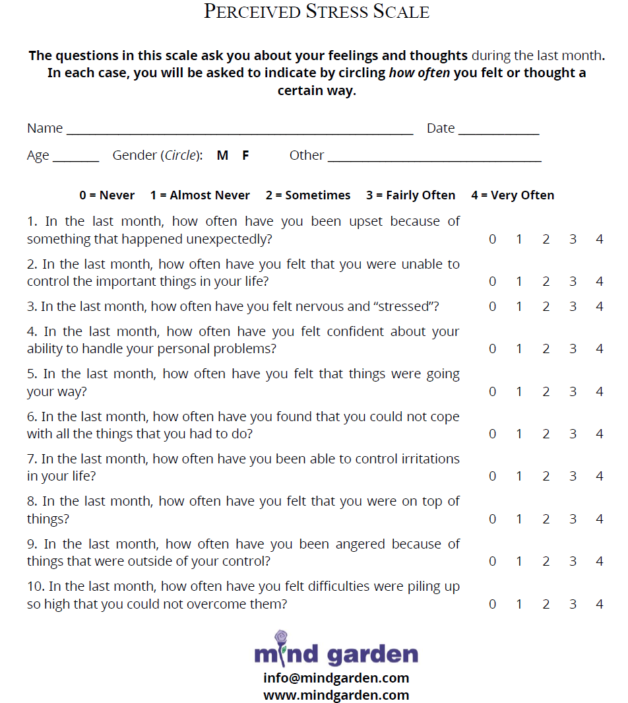
Scoring for this instrument:
- Overall Score
- Two sub-scores
  - Perceived Helplessness – Questions 4, 5, 7, and 8
  - Perceived Self-Efficacy – Questions 1, 2, 3, 6, 9, and 10
Note: The perceived helplessness items are reserve coded on this survey. Thus, when an overall score is computed, adjustments must be made.

Questions:
- What is the average inter-item correlation for the overall score? What is this value for each of the sub-scores? Provide an interpretation of each of these values?

- Which items appear to have the strong correlation with each other? Why might it be that these two items are strongly correlated? Discuss.
- Compute Cronbach’s alpha for the overall score. Provide an interpretation of this value. Compute Cronbach’s alpha for each of the sub-scores. Again, provide an interpretation of this value.

- Use the split-half reliability approach to compute the Spearman-Brown corrected internal consistency correlation for the overall score. Interpret this value.

- As discussed in class, the split-half reliability is influenced by how the items are split into the two halves. Write a small simulation study to investigate how different randomly divided splits affect this measure.

