Example 3.1: Williams-Beuren syndrome (WBS) is a rare neurodevelopmental disorder which is caused by the deletion of more than 25 genes from region q11.23 of chromosome 7. Subjects with WBS display smaller brain volumes than normal; however, they often show an excess of volume in the right occipital cortex region of the brain. There are many documented effects of WBS, e.g., increased risk of cardiac problems, higher risk of diabetes, etc. The study presented here is concerned with the left-handedness of people with WBS.

Research Question: Do males with Williams-Beuren syndrome have a greater chance of left-handedness than males in the general population?
Number of Males in Study with WBS that were Left-Handed Left-Handedness Rate for Males in the General Population  8 out of 25 12.4% | Right Occipital Cortex  Region of Brain
Source: Van Strien, J.W., Lagers-van Haselen, G.C, van Hagen, J.M, de Coo, I.F.M, Fens, MA, van der Geest, JN. (2005). “Increased prevalences of left-handedness and left-eye sighting dominance in individuals with Williams-Beuren syndrome.” Journal of Clinical and Experimental Neuropsychology. 2005 Nov;27(8):967-76.

Specify the setup using the number line below for the evaluation of this research question.

Identify the following simulation parameters for your investigation.
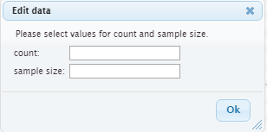 | 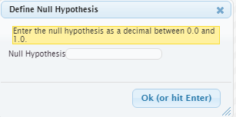

Next, plot the outcomes from your repeated iterations.
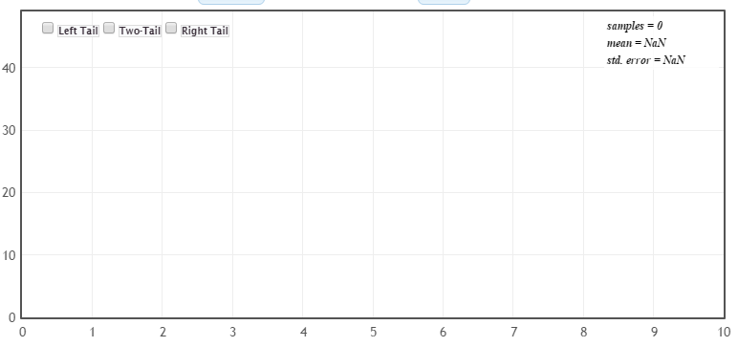
Answer the following questions regarding this investigation.

- Which of the following statements is most correct regarding the above reference distribution?
- The dots on this reference distribution were constructed under the assumption that males with WBS have a greater prevalence of left-handedness because of the excess volume of the right occipital cortex region of the brain.
- The dots on this reference distribution were constructed under the assumption that males with WBS have a greater prevalence of left-handedness than males in the general population.
- The dots on this reference distribution were constructed under the assumption that males with WBS have the same left-handedness rate as males in the general population.
- Circle a single dot on the above dotplot. Complete this sentence to explain what this single dot represents. In this particular simulated outcome, there were ______ out of a possible ______ left-handed WBS male subjects. This dot was generated under the assumption that ______________________________________ _____________________________________________________________________________________________________________________________________________________________________________.

- Consider once again the research question for this investigation.
Research Question: Do males with Williams-Beuren syndrome have a greater chance of left-handedness than males in the general population?
The right-tail of this reference distribution is the tail of interest for this investigation. Why is this the case?

- What is a reasonable cutoff for this investigation? That is, what values would indicate an increased rate of left-handedness for males with WBS?

Cutoff: _______________

- The number of males in this study that were left-handed was 8. Using your reference distribution, do you believe 8 provides enough evidence to support the research question? Explain.

In the general population, the rate of left-handedness rate for females is slightly lower than males. Conduct a Google search to determine a reasonable rate of left-handedness for females.
Suppose the study completed above was done on Females. Identify the following simulation parameters for your investigation and obtain the appropriate reference distribution for an investigation of females.

Plot the outcomes from your repeated iterations.
Questions
- How is the reference distribution for females different than the reference distribution for males?

- Should we expect the cutoff value for females to be higher or lower than the cutoff value for males? Explain.
Example 3.2: Consider the following snip-it of an article published in Sports Illustrated. This article is about a 19 year-old pitching prospect that was drafted by the Baltimore Orioles in the 1st round. The author of this article speaks to the risk of drafting and thereby compensating pitchers taken in the 1st round.
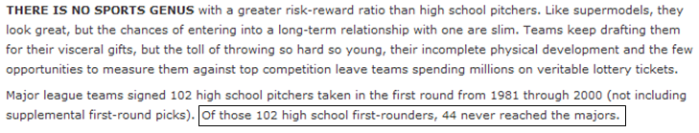
In an effort to determine whether or not pitchers are of a greater risk of failure, we must compare them to other position players. A quick Google® search produces the following information.  In this article, the author states than 66% of 1st round draft picks play in the major leagues and 34% end up never reaching the major leagues. | 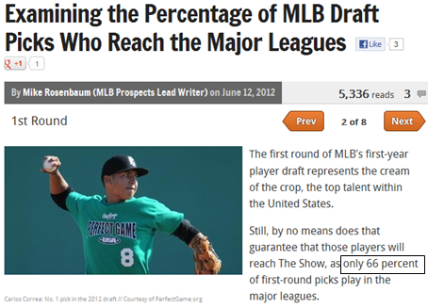
Research Question: Do pitchers taken in the 1st round of the draft have a higher risk of failure than other position players.
Specify the setup using the number line below for the evaluation of this research question.

# Failed to make it to the majors

Identify the following simulation parameters for your investigation.

Next, plot the outcomes from your repeated iterations.
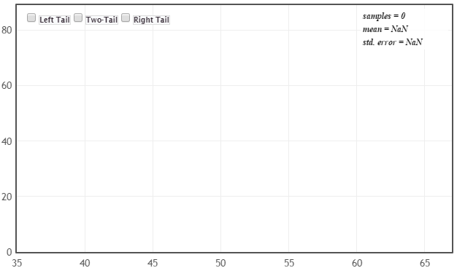
Questions:

- Which of the following statements is most correct regarding the above reference distribution?
- The dots on this reference distribution were constructed under the assumption that pitchers had the higher risk of failure as other position players.
- The dots on this reference distribution were constructed under the assumption that pitchers had the same rate as failure as other position players.
- The dots on the reference distribution were constructed under no assumptions as this would bias our decisions regarding the pitchers.

- Consider once again the research question for this investigation.
Research Question: Do pitchers taken in the 1st round of the draft have a higher risk of failure than other position players.
Which tail of the distribution is of interest for this investigation. Explain your answer.

- What is a reasonable cutoff for this investigation? That is, what values would indicate that pitchers have an increased risk of failure?

Cutoff: _______________

- The number of first-round high school pitchers that never reached the majors is 44. Using your reference distribution, do you believe provides enough evidence to support the research question? Discuss.

Suppose your friend decided to analyze the number that made it to the majors instead of the number that failed to make it.

# Made it to the majors

Construct a reference distribution for this investigation.

Questions
- Do you reach the same conclusion as above when analyzing # Made it to the majors? Briefly discuss.

Example 3.3: Ear Infections (Source: Rosner)
A common symptom of otitis media (ear infection) in young children is the prolonged presence of fluid in the middle ear. The hypothesis has been proposed that babies who are breast-fed for at least 1 month may build up some immunity against the effects of the condition. A small study of 24 pairs of babies is set up, where the babies are matched on a one-to-one basis according to
- age
- Sex
- socioeconomic status, and
- and type of medications taken.
One member of the matched pair is a breast-fed baby and the other was bottle-fed.

The primary outcome measurement recorded in this study was the duration (in days) of fluid in the middle ear after the first episode of otitis media. The results from the 24 pairs are below. Of interest is to make comparisons between the breast-fed and bottle-fed babies. These comparisons should be done within each pair of babies because of the auxiliary factors that were considered in this study.

Who did better in head-to-head comparisons?
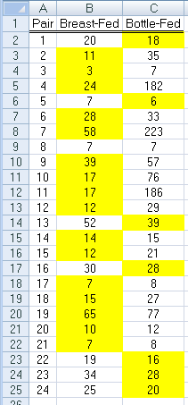

Definition
- Response Variable: The primary outcome or measurement of interest in an analysis.
Also known as: Dependent Variable or Y-Variable

Count the number of times breast-fed and bottle-fed babies did better and complete the following table.

Outcome | Number of Pairs
Bottle-fed did better
Breast-fed did better
Tie
Total | 24

Question

- Pair #8 is a tie, what does this mean in the context of this problem? Does Pair #8 provide evidence for bottle-fed doing better, breast-fed doing better, or neither? Explain.

Research Question: Does type of feeding (i.e. breast or bottle) affect the presence of fluid in the middle ear?
Specify the setup using the number line below for the evaluation of this research question.

# Breast-fed wins

Consider the following pamphlet on Ear Infections in Children from the Department of Health from the State of New York.

Link to Pamphlet: http://www.health.state.ny.us/nysdoh/antibiotic/4815.pdf

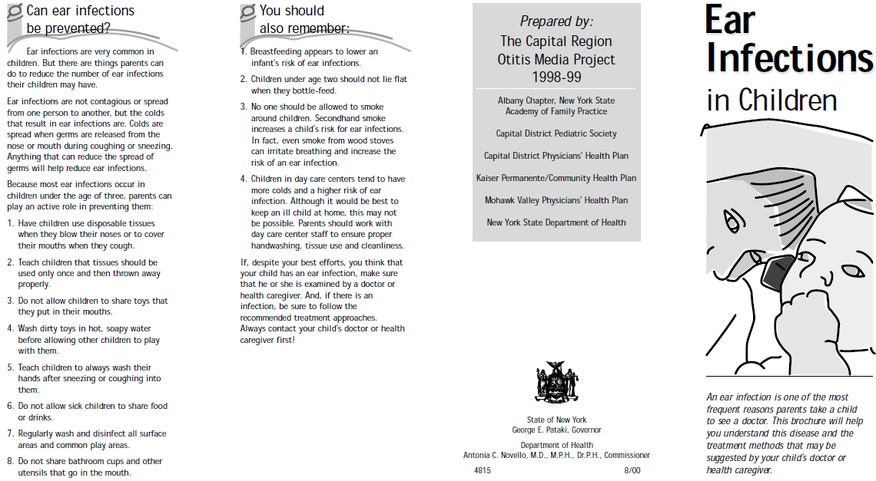

Do a Google search and identify other factors (i.e. called Risk Factors) that are thought to influence the likelihood of a child getting an ear infection.

Mayo Clinic Link: http://www.mayoclinic.com/health/ear-infections/DS00303/DSECTION=risk-factors

Question
- What are some of these risk factors? Discuss their potential influence.

Setting Up an Experiment of this Type
Consider the following mock situation. A researcher has obtained 48 volunteers for their study. They have obtained important demographic variables for each of these 48 study participants and ask you to determine how to best match-up these two sets of participants so that comparisons will be done most fairly.

Goal: Propose a matching strategy for this study using the demographic information provided below. (This data is provided on course web site.)

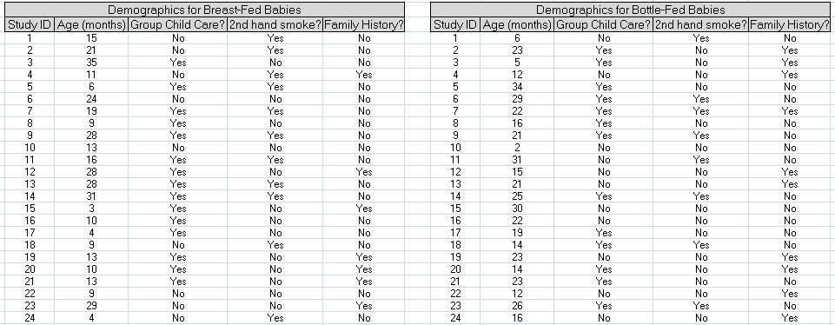

Question
- Discuss the process used for matching these pairs of babies for this mock experiment.
Consider the following mock study participants. Notice the ages for the bottle-fed babies is considerably higher than the ages for the breast-fed babies.
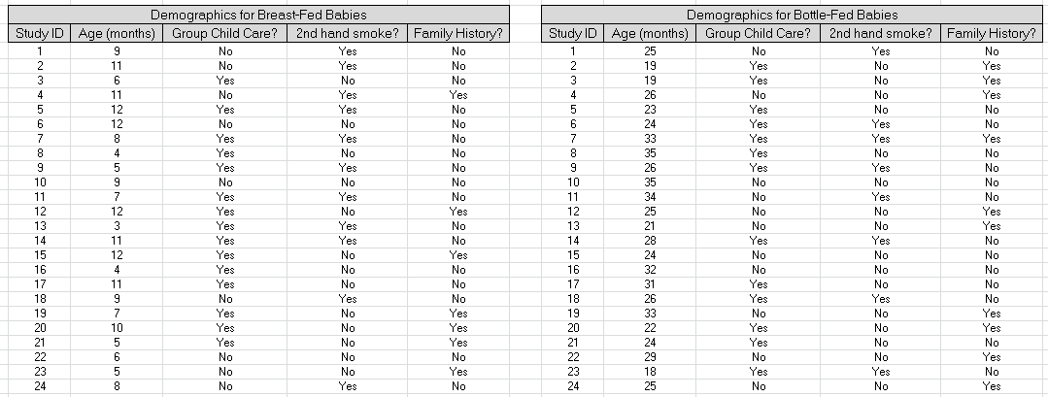
Questions
- Suppose Age is known to influence the occurrence of ear infections. Explain why the differences in the ages between the two groups hinders our ability to compare these two groups.

Definition
- Confounding Variable: A variable that cannot be delineated from another variable when attempting to establish a relationship with the response variable.

In all our analyses thus far, we have been restricted to only two outcomes. Recall, for this example we have three outcomes: 1) breast-fed better, bottle-fed better, and one tie; as a result, when we construct our spinner in StatKey, we will not include the outcome from the tie.

Questions

- If the tie is removed, how many pairs do we have in our sample?

- If there is no difference in the duration of ear infection between breast-fed and bottle-fed, for how many pairs should the bottle-fed babies do better than the breast-fed babies?

Set up a simulation in StatKey to investigate the situation for which there is no difference between the bottle-fed and breast-fed babies. In your simulation, you should track the number of breast-fed pairs.

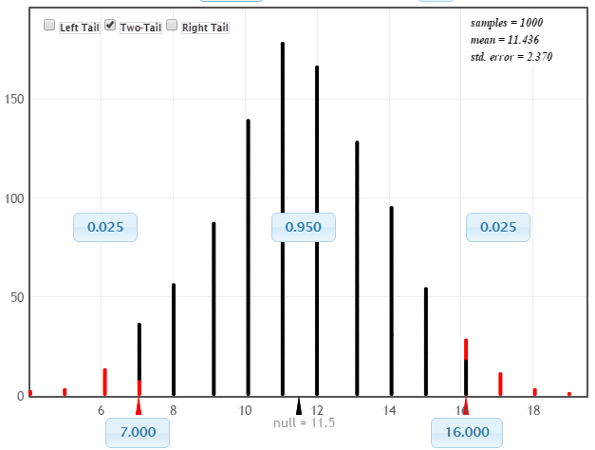

Getting the left-side correct  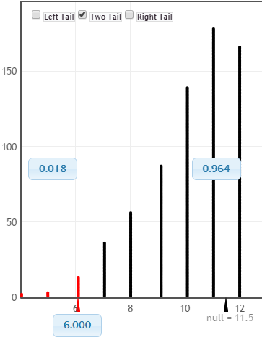 |  | Getting the right-side correct  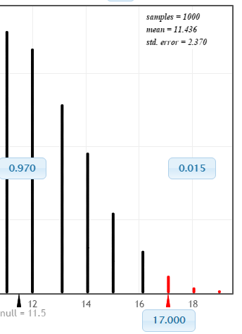

Questions

- What would it mean in the context of this problem, if the outcome from our sample was at the smallest possible value on our graph?

- What would it mean in the context of this problem, if the outcome from our sample was at the largest possible value on our graph?

- Is the outcome from our sample (i.e. 16 pairs for which breast-fed doing better) an outlier? Discuss.

- For this example, we will have two cutoff values. The reason we have two cutoff values is because the original question asked if there was a simply a difference (i.e. no preference to bottle-fed or breast-fed was given).

- Upper cutoff value: _______________

- Lower cutoff value: _______________

- Does the observed outcome from our sample provide enough statistical evidence to suggest breast or bottle fed babies have a lower duration of fluid in their inner ear? Explain.
Example 3.4: Doyle (2002) studied the effect of font type on a brand’s identity and its ability to build the market share of a product. Past research has established the importance of font type in consumer choice. Doyle conducted a small field study involving 40 people in which individuals were asked to select between two boxes of chocolates that were presented to them on a blue tray. To alleviate the potential effect of name recognition on consumer choice, fictitious names were used to identify the two brands – Temptation and Indulgence. Two different font types were compared in this study – Signet and Salem. A total of 30 people (out of the 40) selected the chocolate associated with the Signet font type.

Name of Chocolates | Font Style
 | Signet | Salem
Temptation
Indulgence

To alleviate the possible effect of name on the selection, one-half of the people were presented the Temptation brand using Signet font and the other half were presented the Temptation brand using the Salem font.
½ of the people were presented a tray like this
The other ½ were presented a tray like this

Source: Doyle, J.R. and Bottomley, P.A (2002). “Font Appropriateness and Brand Choice”, Journal of Business Research. Vol. 57, Issue 8, pp873-880.
Questions:
- In the above pictures, the Temptation brand is shown on always shown on the left side of the tray. A statistician might argue that such a setup might introduce bias in this study. Explain why this might be the case?

- How could the potential bias due to the placement (left vs. right) be overcome in this study? Explain.

- Why did the researchers present ½ the people with Temptation using Signet font type and the other half with the Salem font type? In particular, what issues might arise if all participants were presented the Temptation brand using the Signet font type and the Indulgence brand using the Salem font type? Explain.

Research Question: Is there a difference in the preference of the Signet font type and the Salem font type in consumer choice of chocolates?
Specify the setup using the number line below for the evaluation of this research question.

# Picked Signet Font

Identify the following simulation parameters for your investigation.

Next, plot the outcomes from your repeated iterations.
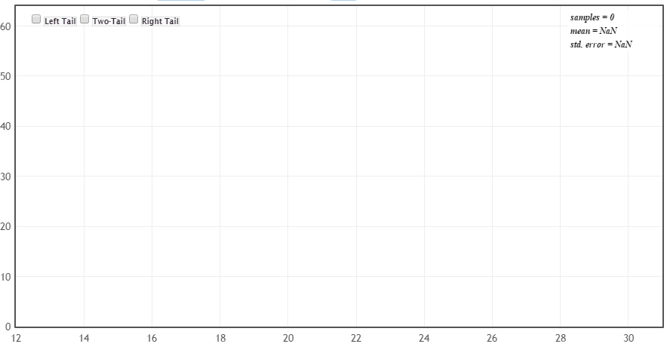

- What are the reasonable cutoffs for this investigation? That is, what values would indicate a preference for one font over the other?

Lower Cutoff: _______________

Upper Cutoff: _______________

- The number of people that picked the Signet font was 30. Is this enough statistical evidence to support the research question?

A little something extra…
Doyle (2002) makes the following statement in his paper.
“One interesting finding is that, in both the main experiments and the pretests, we consistently found no interaction of gender with font. In particular, women do not prefer lighter, more scripted, scrolled (i.e. so-called “feminine”) fonts (such as Signet). This equality between the sexes certainly should make life easier for the company that would use a font to project its brand(s) in mixed-gender markets.”
Doyle does mention in this paper that 21 of the 40 participants were women and 19 were men. From above we know 30 of the 40 choose the Signet font and the remaining 10 choose the Salem font. The following table gives some structure to such outcomes. This is referred to as a 2-by-2 contingency table or a 2x2 cross-tab table.
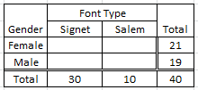
Unfortunately, the authors did not present the actual numbers required to complete this table (e.g. we just know 30 people selected Signet, 21 were female, 19 were male). Below, I have created two fictitious tables – Table A and B.
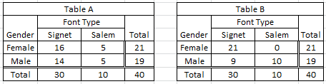
Questions
- In Table A, what proportion of the Females selected the Signet font?

- In Table, A, what proportion of the Males selected the Signet font?

- What proportion of Females selected the Signet font in Table B? What proportion of Males selected the Signet font in Table B?

- Consider the following statement presented in their paper, “…, we consistently found no interaction of gender with font.” Which table, A or B, most likely represents the outcomes from this study? Explain your reasoning?

Example 3.5 Delwiche and Liggett (2004) conducted a study regarding potential differences and preference for wild-caught vs. cultured yellow perch. Judges (n=52) completed 2 replications each of both a paired preference and a triangle test. A triangle test is a type of discrimination test that is commonly used in sensory analysis (e.g. taste test) to determine whether or not there is a detectable difference among two or more items.

Source: Delwiche, J.F. and Liggett, R.E. (2004). “Sensory Preference and Discrimination of Wild-caught and Cultured Yellow Perch”. Journal of Food Science, Vol. 69, Nr. 4.

Type | Can you tell the difference?
Wild-caught | 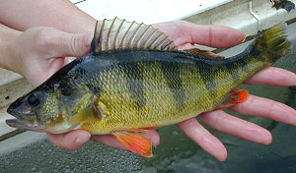
Cultured | 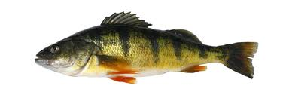

In a triangle test, a judge is presented with three plates and they need to identify the two that “match”.
Plate 1 | Plate 2 | Plate 3

For example, suppose Plate 1 was Wild-caught, Plate 2 was Cultured, and Plate 3 was Cultured. If the judge correctly identifies Plate 2 and 3 as a “match”, then the outcome from this judge would be correct. The triangle test was preformed twice on each of the 52 judges. Below is a snip-it of a mock-up of the data from this study.

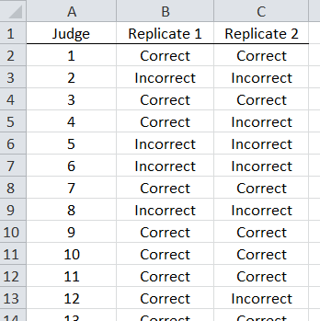

Research Question: Is there enough evidence to say there is a difference in taste between the wild-caught and cultured perch when a triangle discrimination test is used?

The following table includes a summary of the study outcomes presented above. There were a total of 52 judges and each completed two replicates of the triangle test.

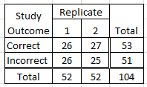
Questions

- How many judges correctly identified the “match” on the first replicate? How about the 2nd replicate?

- Your friend makes the following statement, “Your data is wrong, you cannot have 53 correct “matches” when there are only 52 judges.” Why is this statement incorrect? Explain.

- Your friend makes the following false statement, “When information from both replicates is combined (i.e. 104 total), we can see that only about half (i.e. 53) of the judges correctly identified the “match”; thus, we lack evidence to say these judges can tell a difference.” This statement is false because a triangle test is *not* a 50/50 scenario. What value should your friend be comparing 53 against? Explain.

Identify the parameters for a simulation that would allow you to answer the above research question.

Next, plot the outcomes from your repeated iterations from your simulation.
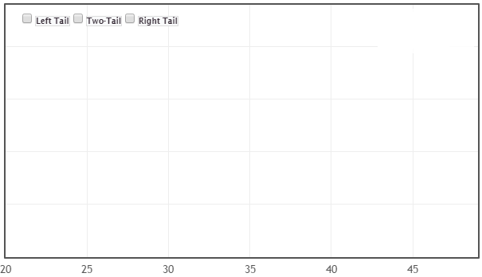

- What are the reasonable cutoff for this investigation? That is, what values would indicate that a difference in taste exists?

- The judges were able to correctly identify the matching plates a total of 53 times (out of 104 trials). Is this enough statistical evidence to suggest a difference exists the taste of wild-caught and cultured yellow perch?

Concept of Repeatability (a.k.a. intra-rater reliability)
Consider the wiki entries for these terms.
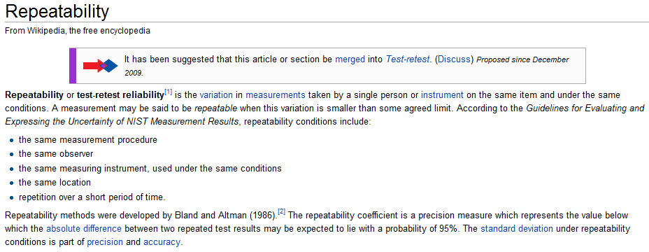

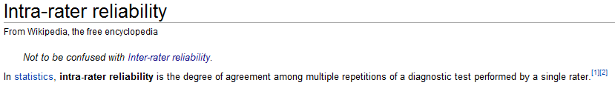

Copy/open the PerchTriangleTest dataset from our course website. Use an =IF() statement to identify whether or not each judge agreed or not on his/her two replicates.

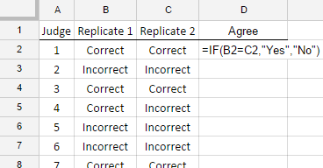

Questions

- Out of the 52 judges, what percent of the judges agreed on their 1st and 2nd replicate?

- Do you feel these judges gave repeatable outcomes across the two replicates? Explain.

- Why is it important to have judges give outcomes that are repeatable in a study like this? Explain.

