STAT 110: Quiz #5 Name(s): _________________________________
Summer 2017
Points: 20 _________________________________

_________________________________
For this quiz, we will investigate how characters in the Friday the 13th horror movies series died. The horror movie Wikipedia type webpage exists and this site was used to gather the information for this quiz.
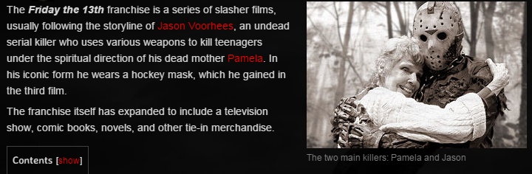

Data Source
- Character Death Lists for various movies: http://horror.wikia.com/wiki/Category:Death_Lists
- Character Death List for Friday the 13th: http://horror.wikia.com/wiki/List_of_deaths_in_Friday_the_13th_series

The following table presents the counts for how people in the Friday the 13th movies series have died, e.g. Blunt force trauma, shot, stabbed, etc. The hat provides the information necessary to compute the expected counts for each death category.

Observed Counts  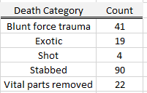 | Use the following hat to get expected counts  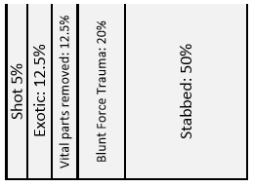

- Complete the following analysis in Excel.

Investigation of Deaths for Friday the 13th Movie Series
Research Question | Does the method of killings that take place in the Friday the 13th movie series differ from the percentages provided from the hat?
Analysis  in Excel | On the following Excel schematic, show me exactly what you did in Excel to obtain the appropriate p-value for your analysis. You should include the observed data, the expected data, and the function used to obtain the p-value. (7 pts)  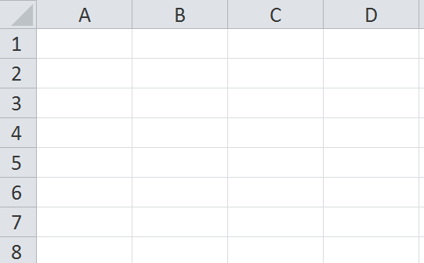  What is the p-value from your test?  P-Value = ___________________
Decision | Make the appropirate statistical decision. Circle the correct decision. (2 pts)  Decision: If the p-value < 0.05, then data is said to support the research question.  - Data supports research question  - Data does not support research question
Conclusion | Write an appropriate conclusion in laymen’s terms and in context. (5 pts)

- Answer the following True/False questions regarding your analysis. (2 pts)

a. | There are several other horror films listed on this website. The conclusion above applies to these other movies. That is, the other movies are within our scope-of-inference. | TRUE | FALSE
b. | A different conclusion will change my scope-of-inference. That is, if the conclusion of this test were different, then the scope-of-inference would change as well. | TRUE | FALSE
c. | Suppose instead of just collecting data from the Friday the 13th movie series, I had randomly collected data from lots of different horror movies listed on this site. Doing this would allow me to expand my scope-of-inference to all horror movies listed on this site. | TRUE | FALSE

