STAT 110: Quiz #4 Name: ______________________________
Summer 2017
Points: 20
The confederate flag symbolizes different things to different people. To some, this symbolizes slavery and all its negative effects; to others this flag represents southern pride. The confederate flag is part of the Mississippi state flag, and until recently was also flown at the South Carolina state capitol. | 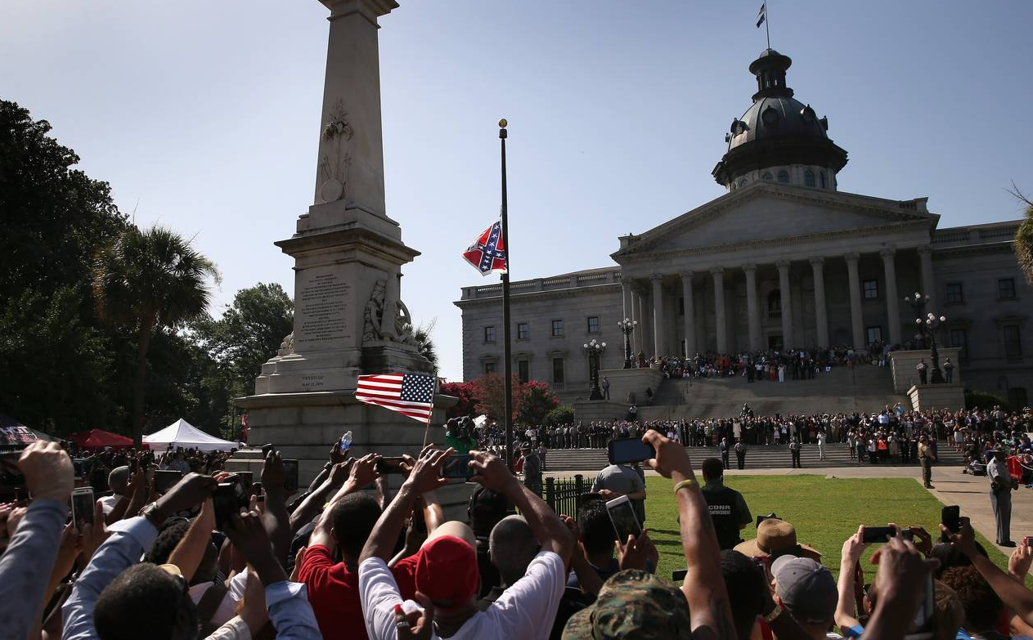
South Carolina governor Nikki Haley called for the confederate flag to be removed following the June 17, 2015 shooting at a church in Charleston, South Carolina in which the black pastor and 8 other church members were slain by a 21-year-old white man hoping to ignite a race war.
Support or opposition to this act varied across race and political ideology. The data provided here are based on a survey conducted by the Pew Research Center in July 2015. This survey asked almost 100 questions; the one in particular we are interested in is Question 83: “As you may know, the South Carolina state government recently voted to take down the Confederate flag from statehouse grounds. In your view, was this the right decision or wrong decision?”

Political Party Affiliation | Removing Flag was “Right Decision” | Removing Flag was “Wrong Decision” | Total
Republican | 184 | 244 | 428
Democrat | 476 | 167 | 643

Consider first an analysis for those that identified themselves as Republicans.
- Provide a sketch of the pyramid that would be used to compute the margin-of-error via simulation for the Republican outcome. (3 pts)

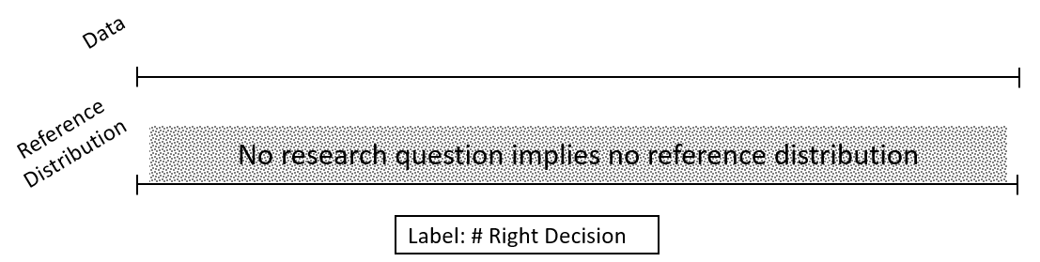

- Specify the probability of heads, number of tosses, and number of repetitions for the simulation that would be used to compute the margin-of-error for the Republican outcome. (3 pts)

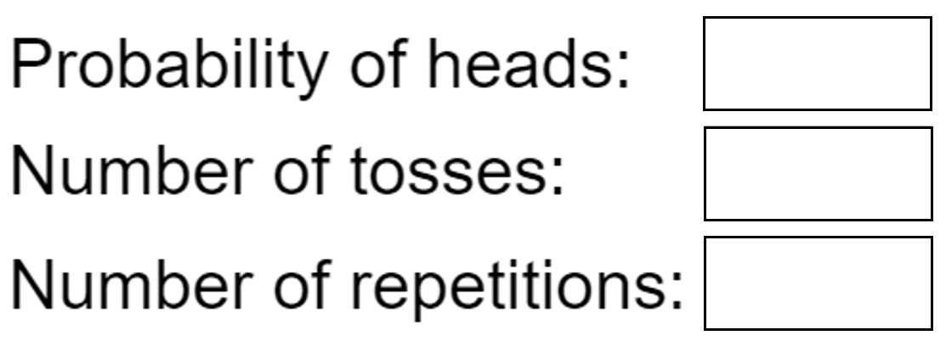

- The next step is to separate the likely outcomes (middle 95%) from the unlikely (outside 5%). Use the “As extreme as” box, labeled Box A below, to specify an appropriate lower (and upper) cutoff. Selecting two-sided with specify both sides. Delete my sample pyramid and replace it with yours. (3 pts)

Simulation App

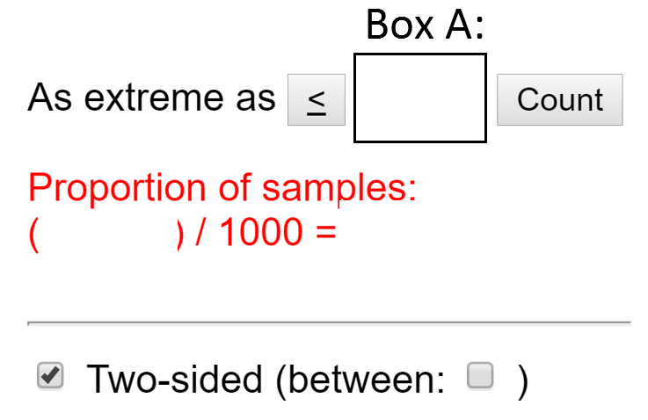 | Delete my sample and copy/paste your pyramid in its place.  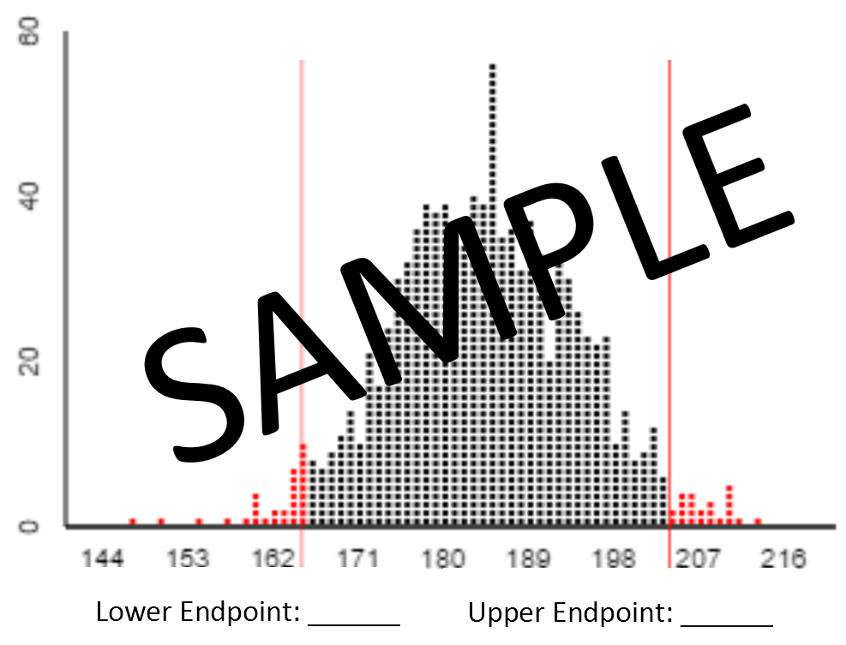

- Use the lower and upper endpoints to compute the – and + margin-of-error via simulation for the Republicans. (2 pts)

$-MOE= \frac{Lower Endpoint-Middle}{Total in Survey}$ =
$+MOE= \frac{Upper Endpoint-Middle}{Total in Survey}$ =

- The more typical method of computing the margin-of-error is via the math formulas. Use the following formulas to compute MOE.

- Compute the value of $\hat{π}$ for Republicans. (1 pt)

$\hat{π}$=
- Compute the margin-of-error for Republicans. (2 pts)

$± MOE: 1.96*\sqrt{\frac{\hat{π}*\left(1-\hat{π}\right)}{n}}$ =

- Use the math formulas to obtain the margin-of-error for the “Right Decision” for Democrats. (2 pts)

$\hat{π}$=

$± MOE: 1.96*\sqrt{\frac{\hat{π}*\left(1-\hat{π}\right)}{n}}$ =

- Your friend decides to compute the margin-of-error for the “Wrong Decision” data instead. Interestingly, she gets exactly the same answer as you. Double check her math. Is she correct – do you get the same answer as well? (2 pts)

- Your friend makes the following comment, “The % that said “Right Decision” for Democrats is higher than the % that said “Right Decision” for Republicans; therefore, the margin-of-error should be higher for Democrats.” This statement is not correct. Why is the margin-of-error for Democrats lower? (2 pts)

