STAT 110: Quiz #3 Name: _________________________________
Points: 20
Summer 2017

Consider the following snip-it of an article published in Sports Illustrated regarding young pitchers in Major League Baseball. This article is centered on 19 year-old pitching prospect that was drafted by the Baltimore Orioles in the 1st round. From 1981 through 2000, a total of 102 high school pitchers were selected in the first round. Of these, 44 never reached the majors.
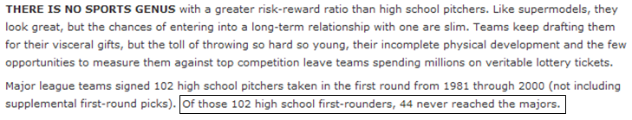
In an effort to determine whether or not pitchers are of a greater risk of failure, we must compare this against the general failure rate. The article to the right provided these figures.  Success/Failure Rate for 1st Round Draft Picks  - 66% of 1st round picks play in the major leagues, and  - 34% never play in the major leagues. | 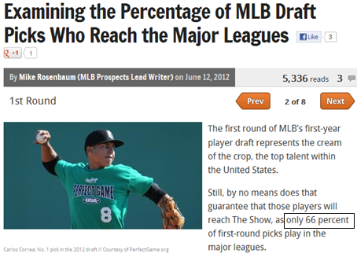
Research Question: Is the failure rate of high-school pitchers taken in the 1st round higher than the general failure rate for major league baseball?
- Identify the smallest possible value, largest possible value, location of the pyramid, and the outcome from the study for this situation on the number lines below. (6 pts)
- Smallest possible value  - Largest possible value  - Location of pyramid  - Outcome from study | 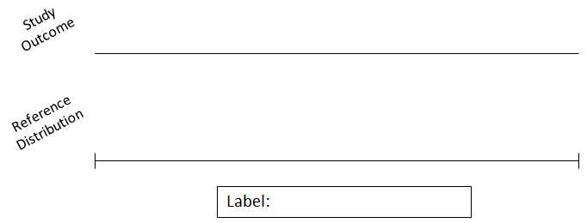  Did Not Make It

- Identify the appropriate set-up for your simulation. Suppose that 100 repeated outcomes is desired. (4 pts)
Identify the following  - Probability of heads  - Number of tosses  - Number of repetitions | 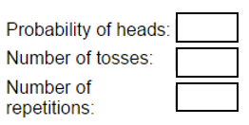
The 100 repeated outcomes are provided below.
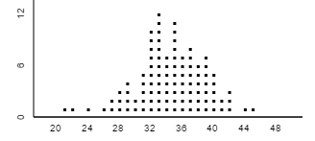
- Which of the following statements is most correct regarding the reference distribution? (3 pts)
- The dots on this reference distribution were constructed under the assumption that high-school pitchers taken in the 1st round have a higher failure rate than others.
- The dots on this reference distribution were constructed under the assumption that high-school pitchers taken in the 1st round have the same failure rate as others.
- The dots on this reference distribution were constructed under the assumption that high-school pitchers taken in the 1st round have a 50% failure rate and 50% success rate.

- Identify what values are used to compute the p-value, compute the p-value, provide a decision, and give a final conclusion using everyday language. (7 pts)
1st Round Pitchers
Research Question | Is the failure rate of high-school pitchers taken in the 1st round higher than the general failure rate for major league baseball?
Parameter | $π$ = the probability that a first round pitcher will not make it to the majors
Identify the values for computing the p-value | What values are as extreme as or more extreme than the observed outcome?
P-Value | P-Value = _______________
Decision | Is the p-value less than 0.05? Circle one.  - If “Yes”, then data is said to provide enough evidence for the research question  - If “No”, then data does not provide enough evidence for research question
Conclusion | Write a conclusion in laymen’s terms.

