STAT 110: Quiz #1 Name(s): __________________________
Points: 20
Summer 2017 __________________________

_____ _____________________

Consider the following Wiki entry for the Swain vs. Alabama Supreme Court case.

http://en.wikipedia.org/wiki/Swain_v._Alabama

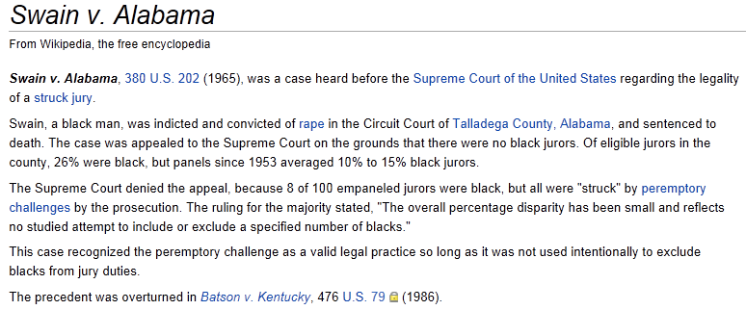

A schematic for picking a jury pool for the Swain vs. Alabama case is provided below. The information for this schematic was provided by Wikipedia.

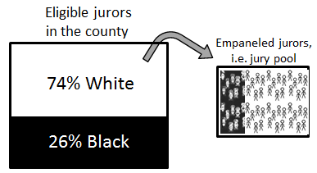

- How many people are selected for the jury pool? (2 pts) _____________

- If the jury pool is selected in a fair manner and without any biases, how many blacks should be in the jury pool? How did you determine this value? (3 pts)

- What is the smallest number of blacks possible in the jury pool? (1 pt) ___________

- What is the largest number of blacks possible in the jury pool? (1 pt) ___________
Next, we will evaluate the following statement which was made by the Supreme Court.

“The overall percentage disparity has been small and reflects no studied attempt to include or exclude a specified number of blacks.”

The following pyramid, which is more formally called a reference distribution, will be used to investigate the likelihood of Swain’s outcome, i.e. observing 8 blacks in the Jury Pool. This reference distribution will allow us to evaluate the statement made by the Supreme Court from a statistical perspective.

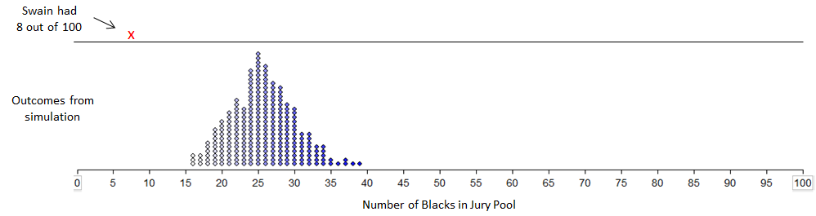

- Which of the following statement is most correct regarding the reference distribution provide above? (4 pts)

- The dots on this reference distribution were obtained under the assumption that the selection of Blacks for the jury pool was done fairly and without any bias.
- The dots on this reference distribution were obtained under the assumption that the selection of Blacks for the jury pool was done in an unfair manner and with bias.
- The dots on this reference distribution were obtained under the assumption that the selection of Blacks for the jury pool may have been done in an unfair manner and with possible bias.

- Swain’s outcome is considerable lower than the outcomes from the pyramid. What does this imply about possible biases in the selection of Swain’s jury pool? Discuss. (4 pts)

- Does your simulation provide evidence for or against the statement made by the Supreme Court? Explain. Your explanation must make use of the pyramid to receive full credit. (5 pts)

