STAT 110: Quiz Name: __________________________
Points: 20

Consider the following data on the homicide victim rate for victims between the ages of 18 and 24. Data was collected for MN and WI over a 25 year period from the U.S. Department of Justice web site.

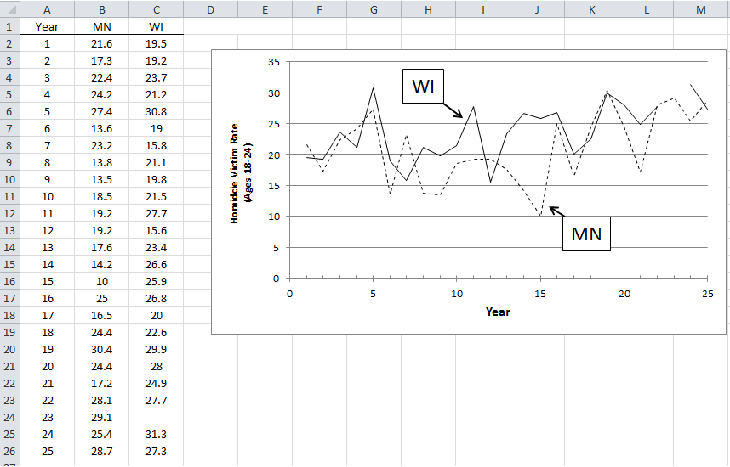

Question of Interest: Are there differences in the homicide victim rates for those victims between the ages of 18 and 24 between MN and WI? If so, what are these differences?
- The first thing a statistician would do with this data is compute the differences in the data from MN and WI. Why would a statistician do this for this type of data? Explain. (3 pts)

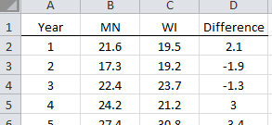

- There is some missing data for WI in Year 23. Your friend suggests putting a 0 in for the missing value so that a difference can be computed for this year. Do you agree or disagree with this suggestion. Explain your reasoning. (3 pts)
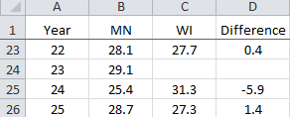

- Consider the following summaries for the differences. Differences were computed as follows.

Difference = MN – WI

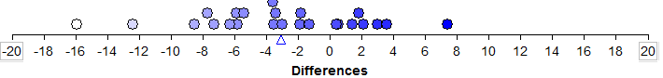

Give a brief discussion of what is learned by considering the above average and standard deviation. (3 pts)

- I ran a statistical test for the above question of interest in Excel. Consider the following output.

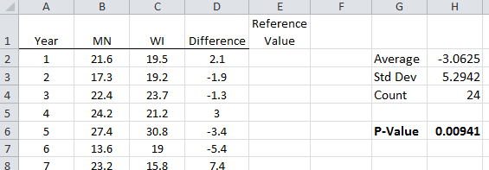

- What reference value did I use to run this test? Explain. (2 pts)

- P-value and decision (1 pt)

P-value: 0.0094

The Decision Rule: If p-value is less than 0.05, then the data supports the question of interest.

- Data supports the research question
- Data does not support the research question

- Circle the most correct conclusion for this test. (4 pts)

- In any given year, we are 95% certain that MN will have a lower homicide rate than WI for the 18-24 age group.
- In any given year, we are 95% certain that there is a difference in the homicide rates between MN and WI for 18-24 age group.
- In any given year, we are 95% certain that WI will have a lower homicide rate than MN for the 18 – 24 age group.
- In any given year, we are 95% certain that there is no difference in the homicide rate between MN and WI for the 18-24 age group.

- I have computed a 95% confidence interval for the difference in the homicide rates between MN and WI. Again, Difference = MN – WI.

Circle the most correct interpretation for this interval. (4 pts)
- In any given year, we are 95% certain that the homicide rate in MN will be about 1 to 5 lower than in WI.
- In any given year, we are 95% certain that the homicide rate in WI will be about 1 to 5 lower than in MN.
- These rates are negative and you cannot have a negative homicide rate, so something is wrong with this interval.
- In any given year, we are 95% certain that the homicide rate between MN and WI is different because this interval does not contain 0.

