STAT 110: Quiz Name: ______________________
Points: 20

The Fools Five is a major regional fundraising event for cancer. This year, Fool’s Five raised over $75,000 for cancer research.
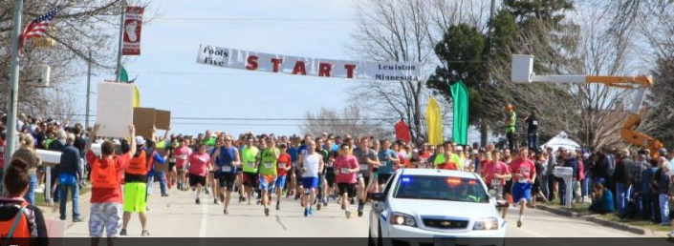 | Race results are provided online  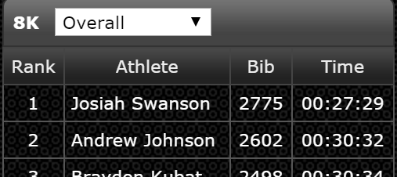

The results from the 2016 Fools Five race are provided on our course website. Download this file. The Mile Pace will be the primary variable of interest for this quiz.

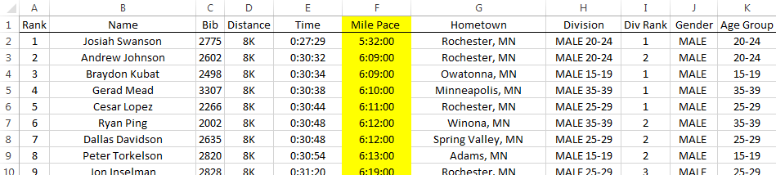

- Compute the average Mile Pace for each age group. Fill in the following table. (5 pts)

Age Groups | Average Mile Pace |  | Getting appropriate summaries  - Specify Average under Value Field Settings  - Change Number Format to reflect Time  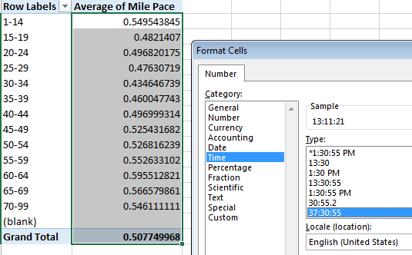
1-14
15-19
20-24
25-29
30-34
35-39
40-44
45-49
50-54
55-59
60-64
65-69
70-99

- Between what two consecutive age groups did Mile Pace times decrease the most? (2 pts)
- Between what two consecutive age groups did Mile Pace times increase the most? (1 pt)
- Use PivotTables and Charts in Excel to create a plot that allow us to compare the average Mile Pace times across the Age Groups for Females and Males separately. (4 pts)

A snippet of the  requested graph  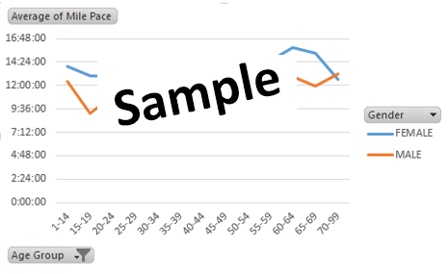 | Provide a sketch of the graph from Excel  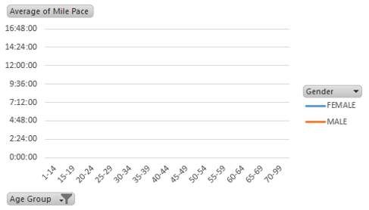

- Physiology differences imply that Mile Pace times are expected to be different across gender. (2 pts)
  - For what age group is the difference in average mile pace times the smallest?
  - For what age group is the difference in average mile pace times the largest?

- Use PivotTable to determine which Age Group has the most consistent mile pace times. Which Age Group is this? (1 pt)
- Is the Age Group with the most consistent mile pace times the same for both genders? Briefly discuss. (2 pts)
- Consider the following CDF plot for Gender = Males, Age Group = 60-64.
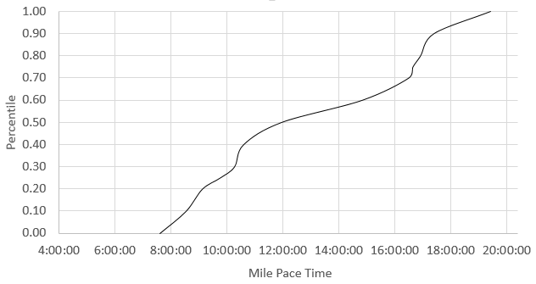
Answer the following (1 pt each)
- The median mile pace time is about ___________.
- About _________ % of the people in this group had a mile pace time under 10 minutes.
- About _________ % of the people in this group had a mile pace time between 12 and 16 minutes.

