STAT 110: Quiz Name: __________________________
Points: 20

Consider Example 4.2.2 from Chapter 4 notes regarding the Donner Party. During the winter of 1846-47, the people making the trek westward established two camps in the mountains -- Alder Camp and Lake Camp (i.e. Truckee Lake Camp). The following table can be used to compare risk of death at each camp.

Camp | Survived |  | Total
 | No | Yes
Alder Camp | 12 | 11 | 23
Lake Camp | 25 | 34 | 59
Total | 37 | 45 | 82

- Suppose you were to find the relative risk ratio for these data as follows:
$$Risk Ratio= \frac{Risk of death at Alder Camp}{Risk of death at Lake Camp}$$
What is this relative risk ratio? (3 pts)
  - (12/11) / (25/34) = 1.48
  - (25/37) / (12/37) = 2.08
  - (12/23) / (25/59) = 1.23
  - (25/82) / (12/82) = 2.08

- Provide the name for the statistical quantity that would be used to fill in the blank in the following sentence? “The risk of death at Alder Camp is _____ times more likely than the risk of death at Lake Camp.” (3 pts)
  - risk difference
  - relative risk ratio
  - odds ratio

- Suppose you were to find the odds ratio for these data as follows:

$$Odds Ratio= \frac{Odds of death at Alder Camp}{Odds of death at Lake Camp}$$
What is this odds ratio? (3 pts)

  - (12/11) / (25/34) = 1.48
  - (37/82) / (45/82) = 0.82
  - (12/23) / (25/59) = 1.23
  - (11/12) / (34/25) = 0.67
- Compute the difference in risk to compare the risk of attempting suicide for those that have been adopted compared against those that have not been adopted. (4 pts)

Show the math:

Interpret this value:

Consider the following graph that shows the relationship between Gender and Reason for Death in fatal car accidents for people whose age is between 18 and 24. This study included deaths from car accidents for 100 women and 200 males.
Goal of Investigation: To compare the Reason for Death across Gender.
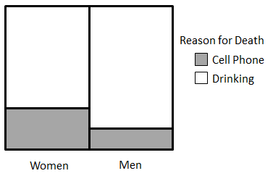
- Answer the following True or False (1 pt each)
a. | T | F | Cell phones are more likely to be the cause of the fatal car accident in women than men.
b. | T | F | Drinking is the cause for more fatal car accidents than cell phones for men.
c. | T | F | Drinking is the cause for more fatal car accidents than cell phones for men and women.
d. | T | F | A woman is less likely to have Drinking be the cause of the fatal car accident than men.
e. | T | F | The risk difference in this plot is zero.
f. | T | F | The outcomes from this investigation can be used to generalize about driving habits of senior citizens, say people over 65.
g. | T | F | This investigation is not fair because the number of women and men in this study were not the same.

