STAT 110: Exam #1 Name:___________________________________
Fall 2016
Points: 100

Consider an investigation into possible racial discrimination in the hiring of coaches in college football. In one given year, 34% of the candidates for head coaching positions were African-American. Of the 18 head coaches actually hired in that particular year, only 2 were African-American.
Research Question: Is there evidence to suggest racial discrimination had occurred in the hiring of African-American head coaches in college football?

Note: For simplicity, you should assume all coaches are equally qualified for these head coaching positions.

- Identify the appropriate setup for this investigation. (6 pts)

- Smallest possible value  - Largest possible value  - Label for number line  - Location of pyramid  - Outcome from study | 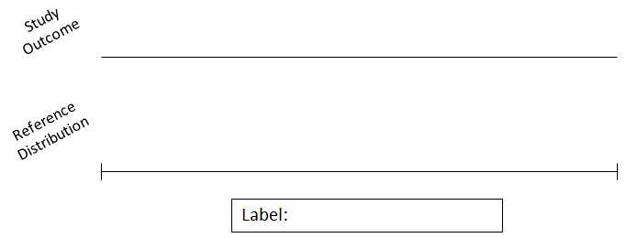

- Specify the correct setup for the Tinkerplot’s spinner. (4 pts)

Consider the following graph of 1000 runs of the simulation.
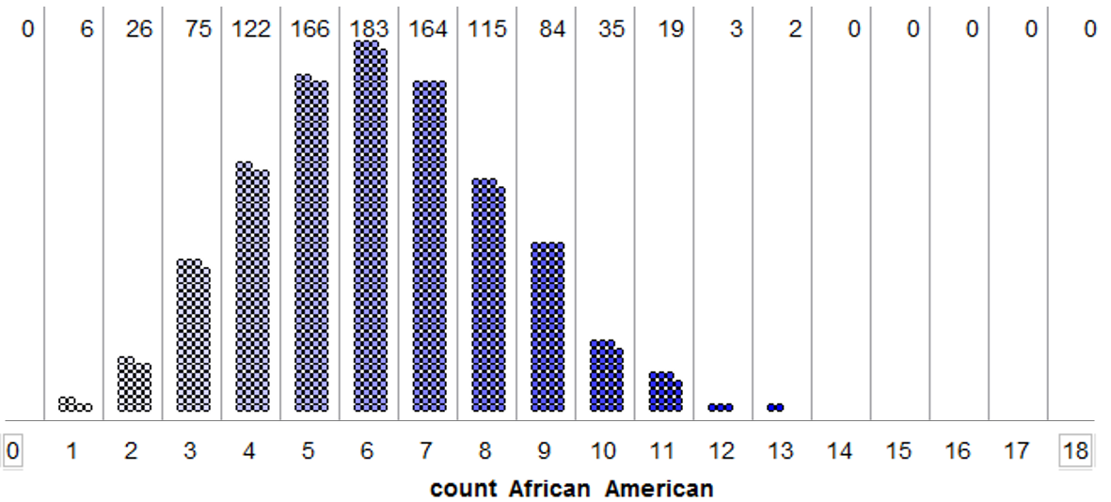
- Answer the following True/False questions. (2 pts each)
a. | This reference distribution was obtained under the assumption that bias was occurring in the hiring of head coaches in college football. | TRUE | FALSE
b. | The above plot shows that 12 African-American coaches were hired out of 18 in 3 of the 1000 runs of this simulation. | TRUE | FALSE
c. | Using the 5% rule and the observed result from the study (2 of the 18 coaches hired were African-American), there is enough statistical evidence to say there is racial discrimination against African-Americans in the hiring of head coaches in college football. | TRUE | FALSE
d. | We would have statistical evidence for discrimination against African-American head coaches if either 5, 6, or 7 coaches were hired because these results occurred most often in our simulation study. | TRUE | FALSE
e. | We do not have evidence enough statistical evidence to say there is racial discrimination against African-American in the hiring of head coaches in college football because the percentage from the data, i.e. 2/18 = 11%, is not below 5%. | TRUE | FALSE

Consider a forced-choice procedure known as the “1 in 5 Test” which can be used to evaluate a patient claiming memory loss. For five seconds, a researcher presents the patient with a card displaying four letters, and the patient is instructed to remember the letters. After a specified delay in time, the subject is shown a second card which shows the same four letters plus one distractor letter that was not on the original card. The patient is then asked to recall any one of the letters that was on the original card.
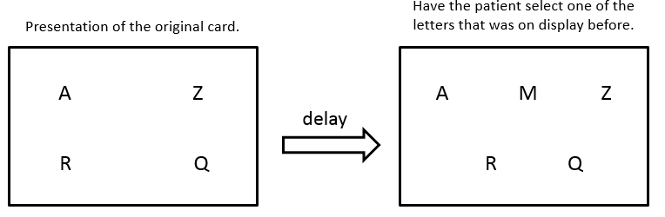

This test is typically conducted a total of 12 times. The number of times that the individual is able to correctly recall a letter on the original card is recorded. A simulation in Tinkerplots will be used to determine what outcomes are likely when a patient does indeed suffer from memory loss and therefore must simply guess when presented with the second card.
- Identify the appropriate setup for the reference distribution. (5 pts)
- Smallest possible value
- Largest possible value
- Label for number line
- Location of pyramid
- Specify the correct setup for the Tinkerplot’s spinner. (4 pts)

- How many of the 12 trials do we expect a patient to answer correctly if they do indeed suffer from memory loss? Show the math for how you computed this value. (3 pts)

- The following graph shows 1000 simulated outcomes that were obtained under the assumption that a patient does indeed suffer from memory loss and hence needed to guess on the “1 in 5 Test.”
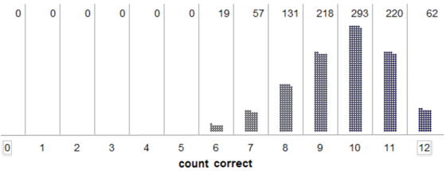

What is an appropriate statistical cutoff for when we believe someone might be faking their memory loss? Briefly explain how you obtained this value. (5 pts)

Cutoff: ______________
Rationale:

Researchers carried out a study to investigate whether two-year-old children learn words through overhearing the conversations of others. In this study, the child sat and watched while the experimenter introduced four new objects to another adult. All four objects were originally placed in a bucket so that they were hidden from sight. One of the four objects was considered the “target” object, and the other three were considered “neutral” objects. For each of the three neutral objects, the researcher would say, “I’ll show you this one” and then pull it out the bucket. However, before introducing the target object to the other adult, the researcher would say, “I’ll show you the toma.” After the child had overheard this conversation between the researcher and the other adult, the researcher presented all four objects to the child and asked him or her to find the “toma.” This was repeated for each of 12 two-year-old subjects. In this study, 10 of the 12 subjects correctly identified the target object.
Research Question: Is there evidence that children learn new words through overhearing? In other words, is there evidence that more two-year-olds are correctly identifying the target object than we would expect if learning does not occur by overhearing?
- Which of the following gives the best description of the scope-of-inference for this this problem? (3 pts)
  - The 12 two-year-olds observed in this study
  - The 10 two-year-olds that correctly identified the target object
  - The percentage of all two-year-olds that would correctly identify the target object
  - All two-year-olds
- Suppose the researchers will conduct a simulation study in Tinkerplots to get an idea of what outcomes to anticipate if the children are really not able to learn new words through overhearing and are simply guessing when asked to find the target object. Which of the following spinners should the researchers use? (3 pts)
- 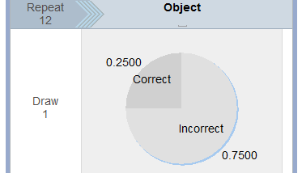 | b. 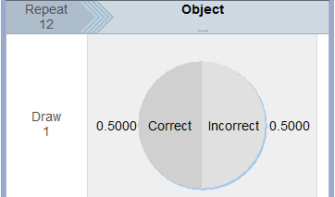
c. 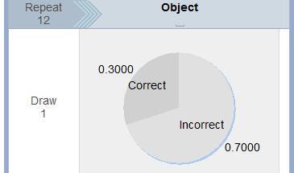 | d. 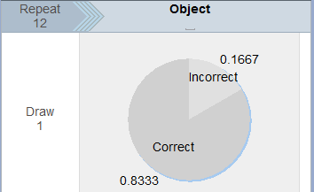

- Suppose the researchers carried out 100 simulated trials of the experiment, and the number of children that correctly identified the target object when guessing was recorded for each simulated trial. The results are summarized below.
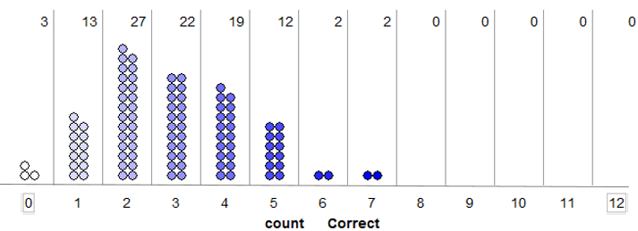
Recall that in the actual experiment, 10 of the 12 children correctly identified the target object. Which of the following is the estimate of the p-value based on this simulation study? (3 pts)
- The p-value is about 0 because 0/100 dots are at 10 or above.
- The p-value is about 1 because 100/100 dots are at 10 or below.
- The p-value is about 83.33% because 10/12 = 83.33% children correctly identified the target object.
- The p-value is about 1/100 = 1% because our goal is to identify the upper 5%, and the closest we can get without exceeding 5% is to find the upper 1%.
- Regardless of your answer above, assume that the results of this study yielded a p-value less than 0.05. Which of the following is a valid conclusion if the p-value is less than 0.05? (3 pts)
  - It would be very surprising to get the observed study result if the two-year-olds were simply guessing when asked to find the target object.
  - It would not be very surprising to get the observed study result if the two-year-olds were simply guessing when asked to find the target object.
  - It would be very surprising to get the observed study result if the two-year-olds were learning through overhearing the conversations of others.
  - It would not be very surprising to get the observed study result if the two-year-olds were learning through overhearing the conversations of others.
- Again, assume the p-value was less than 0.05. Which of the following is a possible explanation for this p-value? (3 pts)
  - The observed result was obtained by chance even though the two-year-olds were guessing.
  - The children are learning through overhearing the conversations of others.
  - Either (a) or (b) are possible explanations for the significant result.
- Reconsider the previous question. Now, think about not possible explanations, but plausible (i.e., reasonable or likely) results. Which is the more likely explanation for the significant result? (3 pts)
  - The observed result was obtained by chance even though the two-year-olds were guessing.
  - The children are learning through overhearing the conversations of others.
  - (a) and (b) are equally likely explanations.

Suppose the prevalence of left-handedness in the general population is 10%. Researchers have obtained a sample of 86 patients diagnosed with hemifacial microsomia (HFM), a condition that affects the development of the lower half of the face, and 22 of the 86 patients were left-handed (22/86 = 26%).
Research Question: Is the prevalence of left-handedness higher for those diagnosed with HFM than for the general population?
- Which of the following gives the best description of the scope-of-inference for this problem? (3 pts)
- The general population
- Those diagnosed with HFM
- The 86 patients in this study
- The 22 patients in this study who are left-handed
- Suppose the researcher plans to use the binomial distribution to find a p-value for this study. What values should be used for n and π? Note: n = number of trials and π is the parameter, i.e. the percentage used to build the reference distribution. (3 pts)
- n = 22, π = .50  - n = 22, π = .10  - n = 22, π = .26 | - n = 86, π = .50  - n = 86, π = .10  - n = 86, π = .26

- The p-value for this study is found to be 0.00002. Which of the following conclusions is most appropriate? (3 pts)
- This study provides statistical evidence that the prevalence of left-handedness is greater for those diagnosed with HFM than for the general population.
- This study does not provide statistical evidence that the prevalence of left-handedness is greater for those diagnosed with HFM than for the general population.
- This study provides statistical evidence that the prevalence of left-handedness of those diagnosed with HFM is 10%, just like it is for the general population.
- This study provides statistical evidence that more than 10% of the HFM patients in this study were left-handed; however, it does not allow us to draw any conclusions about the entire population of patients affected by HFM.

- A student participates in a Coke versus Pepsi taste test. She correctly identifies which soda is which four times out of six tries. She claims that this proves that she can reliably tell the difference between the two soft drinks. You have studied statistics and you want to determine the probability of anyone getting at least four right out of six tries just by chance alone. Which of the following would provide an accurate estimate of that probability? (4 pts)
- Have the student repeat this experiment many times and calculate the proportion of times she correctly distinguishes between the brands.
- Simulate this on the computer with a 50% chance of guessing the correct soft drink on each try, and calculate the proportion of times there are four or more correct guesses out of six trials.
- Repeat this experiment with a very large sample of people and calculate the percentage of people who make four correct guesses out of six tries.
- All of the methods listed here would provide an accurate estimate of the probability.
Consider the following poll found on the Minneapolis Star Tribune website. This poll was centered around Matt Birk, a former Minnesota Vikings player, decision to not visit the White House with his teammates. He refused to visit with President Obama because of Obama’s stance on abortion.

For the following questions, you can assume
- That a sufficient number of people took this online poll
- That the people that took this poll were representative of people who are online readers of the Star Tribune newspaper.

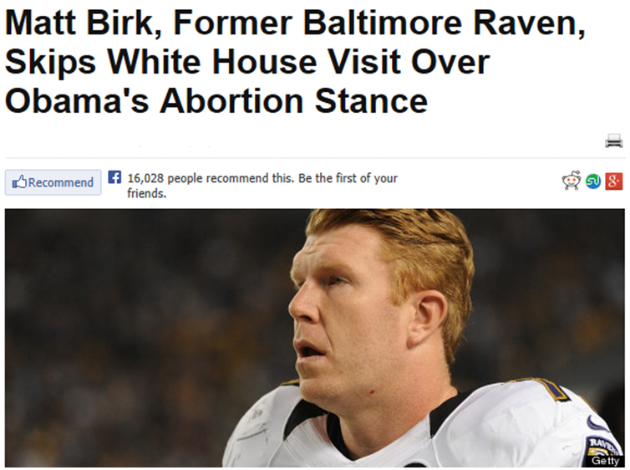 | 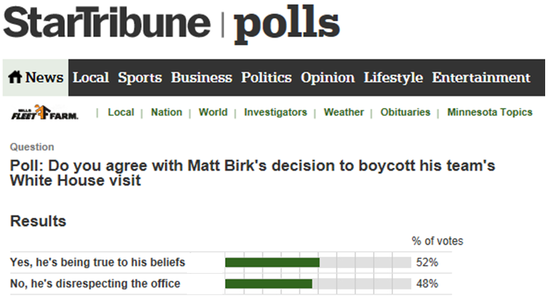

- Answer the following True/False questions regarding this poll. (2 pts each)

a. | For the people who took this online poll, a majority agree with Matt Birk’s decision to not visit the White House. | TRUE | FALSE
b. | For all the online readers of the Star Tribune, we can say that a majority agree with Matt Birk’s decision to not visit the White House. | TRUE | FALSE
c. | A small number of people from California read the online version of the Minneapolis Star Tribune. These people are not in the scope-of-inference for this poll because they do not live in MN. | TRUE | FALSE
d. | The outcomes from this poll cannot be trusted because abortion is a sensitive issue. | TRUE | FALSE
Suppose three years from now you are visiting one of your old college roommates who has since married and has had a child. Your old roommate brags, a bit too much, about how smart their child is throughout your visit. In fact, your old roommate claims their 9 month old child knows his colors.
After obtaining permission from your old college roommate, you decide to test whether or not their child really does know his colors at 9 months old. You set up a small study with four colors (green, red, yellow, and blue). You ask the child to pick up a certain color block and record whether or not the child’s selection was correct. Initially, you set the study up for 30 trials, but the child threw a tantrum and you were only able to record 28 trials. This child correctly identified the color on 14 of the trials.
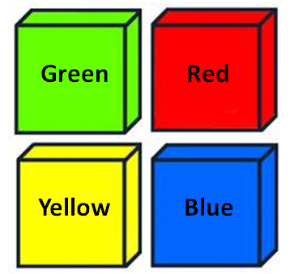
Research Question: Does this child really know his colors at 9 months old?

Answer the following questions regarding the setup of a reference distribution that would allow us to investigate this situation.

- Identify the most appropriate labels on the spinner. (3 pts)
  - Green, Red, Yellow, Blue
  - Correct Guess, Incorrect Guess
  - Child Only Knows These Four Colors, Child Knows All His Colors

- The appropriate proportions on the spinner are (3 pts)
a. 0.50 / 0.50
b. 0.25 / 0.75
c. 0.125 / 0.875
d. None of the above

- The Repeat value on the spinner would be (2 pts)
a. 28
b. 30
c. 12

- More True / False Questions… (2 pts each)

a. | The point for which we start to believe the outcome is an outlier value is found near the upper or lower end of the reference distribution. | TRUE | FALSE
b. | When using a standard 5% error for a one-tailed problem, the cutoff value for when we start to believe we have an outlier always includes either the top 5% or the bottom 5% of the dots from the simulation. | TRUE | FALSE
c. | When using a standard 5% error for a two-tailed problem, you use the top 5% of the dots and the bottom 5% of the dots in order to find the cutoff values for when we start to believe you have an outlier. | TRUE | FALSE
d. | A parameter, denoted by$π$, is required to build a reference distribution. | TRUE | FALSE
e. | The p-value is computed by determining the proportion of dots that are as extreme as or more extreme than the outcome from the study. | TRUE | FALSE
f. | You need to know the outcome from the study before a reference distribution can be created. | TRUE | FALSE
g. | The binominal probability distribution has no assumptions or conditions for its use and can be used in any statistical analysis. | TRUE | FALSE
h. | If the p-value is small, then it is said that the data supports the research question. | TRUE | FALSE

